MODIFIED AES ALGORITHM WITH CHAOTIC MAPPING
SUBBYTES & DYNAMIC SHIFTROWS

PALLA JITHENDRA
L00124300009

Under the guidance of
Dr. B. REDDAIAH
Associate Professor
Department of Computer Science and Technology
YOGI VEMANA UNIVERSITY COLLEGE
KADAPA
Re – Accredited by NAAC’ A’ Grade with CGPA of 3.13/4.0(2nd cycle)
Vemanapuram, kadapa,
Y.S.R. Kadapa -516005, Andhra Pradesh
www.yvu.edu.in

MODIFIED AES ALGORITHM WITH CHAOTIC MAPPING
SUBBYTES & DYNAMIC SHIFTROWS

Project report submitted in partial fulfillment of the requirement for the award of the Degree of MCA (MASTER OF COMPUTER APPLICATION)
BY
NAME: PALLA JITHENDRA
NUMBER: L00124300009


Departmement of Computer Science and Technology
Yogi Vemana University College kadapa
Re-accredited by NAAC’A’ Grade with CGPA of 3.13/4.0 (2ndCycle) Vemanapuram, kadapa,
Y.S.R. Kadapa -516005, Andhra Pradesh.
2025

CERTIFICATE
This is to certify that the project report entitled MODIFIED AES ALGORITHM WITH CHAOTIC MAPPING SUBBYTES & DYNAMIC SHIFTROWS being submitted by PALLA JITHENDRA in partial fulfilment for the award of the Degree of Masters of Technology in Computer Science and Technology to Yogi vemana university college kadapa is a record of bonafied work carried out under my guidance and supervision.

The results embodied in this project report have not been submitted to any other University or Institute for the award of any Degree or Diploma.

(Project Guide)
Designation
Head of the Department

External examiner

DECLARATION

I hereby declare that the project entitled MODIFIED AES ALGORITHM WITH CHAOTIC MAPPING SUBBYTES & DYNAMIC SHIFTROWS has been carried out by PALLA JITHENDRA (L00124300009) and this work has been submitted to DEPARTMENT OF COMPUTER SCIENCE AND TECHNOLOGY.

I further declare that this project work has not been submitted in full or part for the award of any other degree of this on any other educational institutions.

DATE: SIGNATURE OF THE CANDIDATE
PLACE: KADAPA PALLA JITHENDRA
(L00124300009)

ACKNOWLEDGEMENTS
The satisfaction that accompanies the successful completion of any task would be incomplete without mention of the people, who made it possible whose constant guidance and encouragement crowned our efforts with success. We take this opportunity to express my deepest gratitude and appreciation to all those who have helped us directly or indirectly to words the successful completion of this project.
It is great pleasure in expressing deep sense of gratitude and veneration to our guide, DR.B. REDDAIAH Associate professor Department of Computer Science and Technology (MCA (cs)) for his valuable guidance and thought-provoking discussion throughout the course of project work.
I take the opportunity to offer gratefulness to our head of department of Dr.K.SRINIVASA RAO Associate professor of Computer Science and Technology (MCA (cs)) for providing all sorts of help during the project.
I take the opportunity to offer gratefulness to our principal of the college Prof Dr.T.SREENIVAS for providing all sorts of help during the project work.
I express our thanks to all our college teaching and non-teaching staff members who encouraged and help us in some way or other throughout the project work.
Finally, I am thankful to all our friends who have in some way or the other helped us in getting towards the completion of this project work.
Abstract
The Advanced Encryption Standard (AES) is a widely adopted symmetric key encryption algorithm recognized for its balance between security and computational efficiency. However, with the rapid advancement of cryptanalysis techniques and increasing data security requirements, there is a growing need to explore modifications that can further strengthen AES against emerging threats. This project presents a modified version of the AES algorithm designed to enhance its cryptographic strength and overall security performance. The modification focuses on altering two of the four fundamental operations in the standard AES structure while retaining its overall framework and key scheduling mechanism. By strategically changing selected operations, the proposed design aims to improve confusion and diffusion characteristics, thereby increasing resistance to differential and linear cryptanalysis.
The modified algorithm has been analyzed and compared with the standard AES using various performance metrics, including avalanche effect, entropy, correlation coefficient, and computational complexity. Experimental results indicate that the proposed modifications lead to a significant improvement in avalanche properties and randomness, demonstrating enhanced diffusion and key sensitivity. Furthermore, the algorithm maintains comparable execution time and efficiency to the standard AES, ensuring its practicality fors real-time applications. Overall, the proposed modified AES provides a stronger and more secure encryption framework while preserving the efficiency and structure of the original algorithm, making it a viable candidate for modern data security applications.

 | TABLE OF CONTENTS
S.NO | CONTENT | PAGE NO
1 | INTRODUCTION  - AES ALOGRATHAM INTRODUCTION  - PROJECT PURPOSE | 1  1  1
2 | NOTATION AND CONVENTIONS  - INPUTS AND OUTPUTS  - BYTES  - INDEXING OF BYTE SEQUENCES  - THE STATE  - ARRAYS OF WORDS | 3  3  3  3  4  5
3 | MATHEMATICAL PRELIMINARIES  - ADDITION IN GF(28)  - MULTIPLICATION IN GF(28)  - MULTIPLICATION OF WORDS BY A FIXED MATRIX  - MULTIPLICATIVE INVERSES IN GF(28) | 6  6  6  8  8
4 | ALGORITHM SPECIFICATIONS  - CIPHER()  - CHAOTIC MAPPING SUB BYTES()  - CHAOTIC LOGISTIC MAP  - BURN-IN (TRANSIENT REMOVAL)  - GENERATING 256 CHAOTIC NUMBERS  - SORTING→CREATING A PERMUTATION  - ENCRYPTION S-BOX  - DECRYPTION (INVERSE S-BOX)  - EXAMPLE CALCULATION  - DYNAMIC SHIFTROWS()  - MIXCOLUMNS()  - ADDROUNDKEY()  - KEYEXPANSION()  - INVCIPHER()  - INV DYNAMIC SHIFTROWS  - INV CHAOTIC MAPPING SUBBYTES()  - INVMIXCOLUMNS()  - INVERSE OF ADDROUNDKEY()  - EQINVCIPHER()  - KEYEXPANSIONEIC() | 9  10  12  12  12  12  13  13  13  14  15  16  17  18  20  21  22  22  23  24  26
5 | WORKING WITH AN EXAMPLE  - STARTING ENCRYPTION  - STARTING DECRYPTION | 28  28  29
6 | COMPARISON WITH STRANDED AES WITH MODIFIED AES.  - COMPARE METRICS  - AVALANCHE EFFECT ANALYSIS  - BIT INDEPENDENCE CRITERION (BIC) ANALYSIS  - KEY-DEPENDENT SHIFT-SCHEDULE ENTROPY ANALYSIS  - AVALANCHE ONSET ROUND ANALYSIS  - BLOCK AVALANCHE EFFECT ANALYSIS  - KEY-DEPENDENT SHIFT-SCHEDULE ENTROPY ANALYSIS | 31  31  32  33  33  34  34  35
7 | CONCLUSION | 37
8 | PROGRAMMING CODES  - CREATE A S-BOX BOTH ENCRYPTION AND DECRYPTION  - MODIFIED AES ALGORITHM | 39  39  40

 | LIST OF FIGURE
FIGURE NO | NAME OF THE FIGURE | PAGE NO
1 | AES 128 BITS STRUCTURE | 2
2 | STATE ARRAY INPUT AND OUTPUT | 5
3 | BLOCK DIAGRAM FOR AES IMPLEMENTATION | 11
4 | CHAOTIC MAPPING SUB BYTES() TRANSFORMS THE STATE | 14
5 | DYNAMIC SHIFTROWS() | 16
6 | MIXCOLUMNS() | 17
7 | ADDROUNDKEY() | 18
8 | KEYEXPANSION() OF AES-128 TO GENERATE THE WORDS | 20
9 | INV DYNAMIC SHIFTROWS() | 21
10 | INVERSE OF ADDROUNDKEY() | 24
11 | AES KEY EXPANSION WITH FUNCTION G | 26

 | LIST OF TABLES
TABLE NO | NAME OF THE TABLE | PAGE NO
1 | HEXADECIMAL REPRESENTATION OF 4-BIT SEQUENCES | 3
2 | INDICES FOR BYTES AND BIT | 4
3 | KEY-BLOCK-ROUND COMBINATIONS | 9
4 | AES S-BOX FOR ENCRYPTION | 15
5 | ROUND CONSTANTS | 18
6 | AES S-BOX FOR DECRYPTION | 22
7 | COMPARATIVE ANALYSIS SUMMARY TABLE | 38

 | LIST OF ALGORITHM
ALGORITHM NO | NAME OF THE ALGORITHM | PAGE NO
1 | PSEUDOCODE FOR CIPHER() | 10
2 | PSEUDOCODE FOR KEYEXPANSION() | 19
3 | PSEUDOCODE FOR EQINVCIPHER() | 24
4 | PSEUDOCODE FOR KEYEXPANSIONEIC() | 26

1. INTRODUCTION
1.1 AES Algorithm Introduction
In the digital era, the protection of data during storage and transmission has become a critical requirement. Encryption plays a central role in ensuring confidentiality, integrity, and authenticity of information across various communication networks. Among the existing symmetric key encryption algorithms, the Advanced Encryption Standard (AES) has emerged as one of the most secure and efficient standards, widely used in applications such as wireless communication, cloud storage, financial transactions, and secure data sharing.
AES is a block cipher that operates on fixed-size data blocks of 128 bits, using key lengths of 128, 192, or 256 bits. The algorithm consists of multiple rounds, each composed of four fundamental transformations: SubBytes, ShiftRows, MixColumns, and AddRoundKey. Together, these operations provide both confusion and diffusion, which are essential properties for resisting modern cryptanalytic attacks. Despite its proven robustness, continuous advancements in computational capabilities and the discovery of new analytical techniques necessitate further strengthening of the AES structure to meet future security demands.
1.2. Project purpose
This project introduces a modified version of the AES algorithm aimed at enhancing its security performance and resistance to potential attacks. The proposed modification focuses on altering two of the four core AES operations, while retaining the overall framework and key expansion process of the standard algorithm. These modifications are designed to improve the nonlinearity, diffusion rate, and key sensitivity, thereby providing stronger protection against differential and linear cryptanalysis.
The primary objective of this work is to evaluate how selective changes in AES operations can influence cryptographic performance and security characteristics. The modified algorithm is tested and compared with the standard AES using parameters such as the avalanche effect, entropy, correlation coefficient, and encryption/decryption time. The results show that the proposed method achieves better randomness and diffusion while maintaining computational efficiency, demonstrating that carefully designed structural modifications can enhance AES security without compromising its operational speed or simplicity.

AES 128 bits Structure
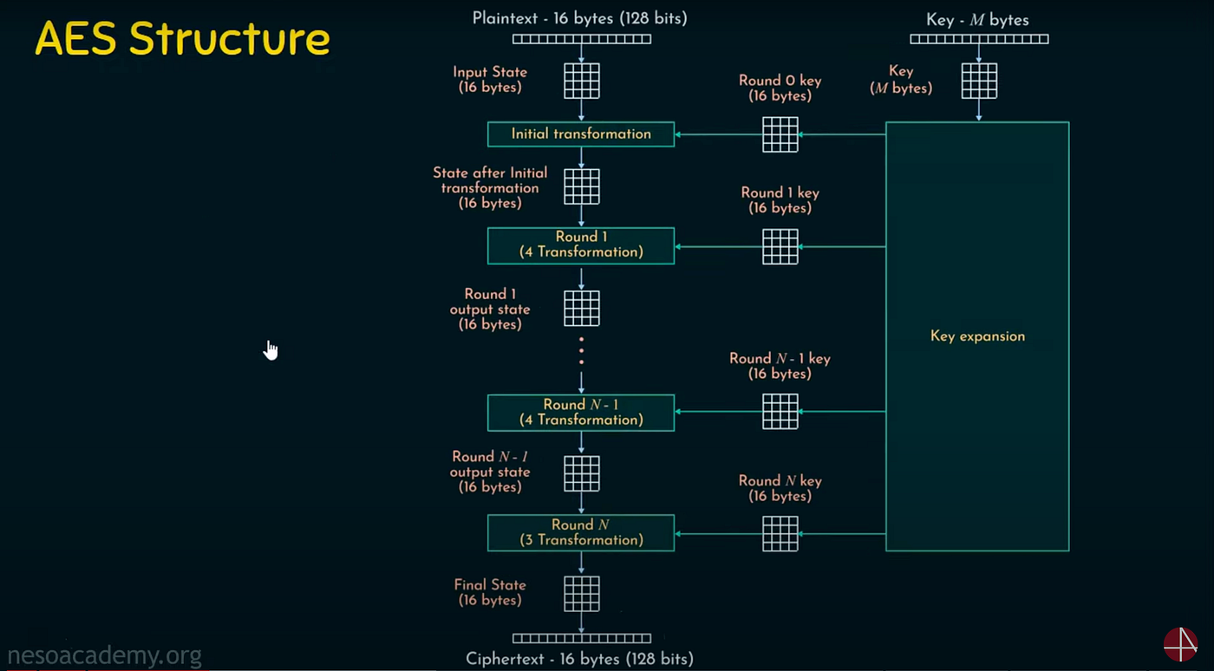
Figure 1:- AES 128 bits Structure

2 NOTATION AND CONVENTIONS
2.1 Inputs and Outputs
A bit is a binary digit — 0 or 1. A block is a sequence of 128 bits; the data input and output for the AES block ciphers are blocks. Another input to the AES block ciphers, called the key, is a bit sequence that is typically established beforehand and maintained across many invocations of the block cipher. The lengths of the keys for AES-128, AES-192, and AES-256 are 128 bits, 192 bits, and 256 bits, respectively.
2.2 Bytes
The basic processing unit in the AES algorithms is the byte — a sequence of eight bits.
A byte value is denoted by the concatenation of the eight bits between braces (e.g., {10100011}). When the bits of a byte are denoted by an indexed variable, the convention in this Standard is for the indices to decrease from left to right (i.e., {b7 b6 b5 b4 b3 b2 b1 b0}).
It is also convenient to denote byte values using hexadecimal notation. The 16 hexadecimal characters represent sequences of four bits, as listed in Table 1. A byte is represented by an ordered pair of hexadecimal characters, where the left character in the pair represents the four left-most bits(i.e., b₇,b₆,b₅,b₄), and the right character in the pair represents the four right-most bits (i.e., b₃,b₂,b₁,b₀). For example, the hexadecimal form of the byte {10100011} is {a3}.
Table 1. Hexadecimal representation of 4-bit sequences
Sequence | 0000 | 0001 | 0010 | 0011 | 0100 | 0101 | 0110 | 0111
Character | 0 | 1 | 2 | 3 | 4 | 5 | 6 | 7

Sequence | 1000 | 1001 | 1010 | 1011 | 1100 | 1101 | 1110 | 1111
Character | 8 | 9 | a | b | c | d | e | f

2.3 Indexing of Byte Sequences
In order to unambiguously represent the data and key inputs as sequences of bytes, the following indexing convention is adopted in this Standard. Given a sequence of 8k bits,

r₀ r₁ r₂ ... r_{(8k−3)} r_{(8k−2)} r_{(8k−1)}
(for some positive integer k), the bytes a_{j} for 0 ≤ j ≤ k −1 are defined as follows:
a_{j} = {r_{8 j} r_{(8 j+1)} ... r_{(8 j+7)}}.
Thus, for example, the data block
r₀ r₁ r₂ ... r₁₂₅ r₁₂₆ r₁₂₇
is represented by the byte sequence
a₀ a₁ a₂ ... a₁₃ a₁₄ a₁₅,
where
a₀ ={r₀ r₁ ... r₇};
a₁ ={r₈ r₉ ... r₁₅};
$⋮$
a₁₅ ={r₁₂₀ r₁₂₁ ... r₁₂₇}.

As described in Section the bits within any individual byte are indexed in decreasing order from left to right. This ordering is more natural for the finite field arithmetic on bytes that is described in Section The two types of bit indices for byte sequences are illustrated in Table 2.
Table 2. Indices for bytes and bit
Bit index in sequence | 0 | 1 | 2 | 3 | 4 | 5 | 6 | 7 | 8 | 9 | 10 | 11 | 12 | 13 | 14 | 15 | …
Byte index | 0 |  |  |  |  |  |  |  | 1 |  |  |  |  |  |  |  | …
Bit index in byte | 7 | 6 | 5 | 4 | 3 | 2 | 1 | 0 | 7 | 6 | 5 | 4 | 3 | 2 | 1 | 0 | …

2.4 The State
Internally, the algorithms for the AES block ciphers are performed on a two-dimensional (four-by-four) array of bytes called the state. In the state array, denoted by s, each individual byte has two indices: a row index r in the range 0 ≤ r < 4 and a column index c in the range 0 ≤ c < 4. An individual byte of the state is denoted by either s_{r,c} or s[r, c].
In the specifications for the AES block cipher algorithms in Section 5, the first step is to copy the input array of bytes in0, in1, ..., in15 to the state array s as follows:
s[r, c] = in[r +4c] for 0 ≤ r < 4 and 0 ≤ c < 4.
A sequence of transformations is then applied to the state array, after which its final value is copied to the output array of bytes out0, out1, ..., out15 as follows:
Out[r +4c] = s[r,c] for 0 ≤ r < 4 and 0 ≤ c < 4.
The correspondence between the indices of the input and output with the indices of the state array is illustrated in Fig. 1.
input bytes state array output bytes
in₀ in₄ in₈ in₁₂ s_{0,0} s_{0,1} s_{0,2} s_{0,3} out₀ out₄ out₈ out₁₂
in₁ in₅ in₉ in₁₃ s_{1,0} s_{1,1} s_{1,2} s_{1,3} out₁ out₅ out₉ out₁₃
in₂ in₆ in₁₀ in₁₄ s_{2,0} s_{2,1} s_{2,2} s_{2,3} out₂ out₆ out₁₀ out₁₄
in₃ in₇ in₁₁ in₁₅ s_{3,0} s_{3,1} s_{3,2} s_{3,3} out₃ out₇ out₁₁ out₁₅
Figure 2. State array input and output

2.5 Arrays of Words
A word is a sequence of four bytes; a block consists of four words. The four columns of state array s are interpreted as an array v of four words as follows, in the notation of Fig. 1:
S_{0,0} S_{0,1} S_{0,2} S_{0,3}
V₀= S_{1,0} V₁= S_{1,0} V₂= S_{1,2} V₃= S_{1,3}
S_{2,0} S_{2,1} S_{2,2} S_{2,3}
S_{3,0} S_{3,1} S_{3,2} S_{3,3}
Thus, the column index c of s becomes the index for v, and the row index r of s becomes the index for the four bytes in each word.
Given a one-dimensional array u of words, u[i] denotes the word that is indexed by i, and the sequence of four words u[i], u[i + 1], u[i + 2], u[i + 3] is denoted by u[i..i + 3].

3. MATHEMATICAL PRELIMINARIES
For some transformations of the AES algorithms specified in, each byte in the state array is interpreted as one of the 256 elements of a finite field, also known as a Galois Field, denoted by GF(2⁸).
In order to define addition and multiplication in GF(2⁸), each byte {b₇ b₆ b₅ b₄ b₃ b₂ b₁ b₀} is interpreted as a polynomial, denoted by b(x), as follows:
b(x) = b₇ x⁷ + b₆ x⁶ + b₅ x⁵ + b₄ x⁴ + b₃ x³ + b₂ x² + b₁ x + b₀.
For example, {01100011} is represented by the polynomial x⁶ + x⁵ + x + 1.

3.1 Addition in GF(28)
In order to add two elements in the finite field GF(2⁸), the coefficients of the polynomials that represent the elements are added modulo 2 (i.e., with the exclusive-OR operation, denoted by ⊕), so that 1 ⊕ 1 = 0, 1 ⊕ 0 = 1, and 0 ⊕ 0 = 0.
Equivalently, two bytes can be added by applying the exclusive-OR operation to each pair of corres-sponding bits in the bytes. Thus, the sum of {a₇ a₆ a₅ a₄ a₃ a₂ a₁ a₀} and {b₇ b₆ b₅ b₄ b₃ b₂ b₁ b₀} is {a₇ ⊕ b₇ a₆ ⊕ b₆ a₅ ⊕ b₅ a₄ ⊕ b₄ a₃ ⊕ b₃ a₂ ⊕ b₂ a₁ ⊕ b₁ a₀ ⊕ b₀}.
For example, the following three representations of addition are equivalent:
(x⁶ + x⁴ + x² + x + 1) + (x⁷ + x + 1) = x⁷ + x⁶ + x⁴ + x² (polynomial)
{01010111} ⊕ {10000011} = {11010100} (binary) (4.2)
{57} ⊕ {83} = {d4} (hexadecimal).

Because the coefficients of the polynomials are reduced modulo 2, the coefficient 1 is equivalent to the coefficient –1, so addition is equivalent to subtraction. For example, x⁴ + x² represents the same finite field element as x⁴ − x², −x⁴ + x², and −x⁴ − x². Similarly, the sum of any element with itself is the zero element.

3.2 Multiplication in GF(28)
�
The symbol • denotes multiplication in GF (2⁸). Conceptually, this multiplication is defined on two bytes in two steps: 1) the two polynomials that represent the bytes are multiplied as polynomials, and 2) the resulting polynomial is reduced modulo the following fixed polynomial:
m(x) = x⁸ + x⁴ + x³ + x + 1
Within both steps, the individual coefficients of the polynomials are reduced modulo 2.

Thus, if b(x) and c(x) represent bytes b and c, then b • c is represented by the following modular reduction of their product as polynomials:
b(x)c(x) mod m(x)
The modular reduction by m(x) may be applied to intermediate steps in the calculation of b(x)c(x); consequently, it is useful to consider the special case that c(x) = x (i.e., c = {02}). In particular, the product b • {02} can be expressed as a function of b, denoted by XTIMES(b), as follows:

{b₆ b₅ b₄ b₃ b₂ b₁ b₀ 0} if b₇=0
XTIMES(b) =
{b₆ b₅ b₄ b₃ b₂ b₁ b₀ 0}⊕{0 0 0 1 1 0 1 1} if b₇ = 1.

Multiplication by higher powers of x (such as {04}, {08}, and {10}) can be implemented by the repeated application of XTIMES(). For example, let b = {57}:
{57}•{01} = {57}
{57}•{02} = XTIMES({57}) = {ae}
{57}•{04} = XTIMES({ae}) = {47}
{57}•{08} = XTIMES({47}) = {8e}
{57}•{10} = XTIMES({8e}) = {07}
{57}•{20} = XTIMES({07}) = {0e}
{57}•{40} = XTIMES({0e}) = {1c}
{57}•{80} = XTIMES({1c}) = {38}.
These products facilitate the computation of any multiple of {57}. For example, because {13} = {10}⊕{02}⊕{01}, it follows that
{57}•{13} = {57}• ({01}⊕{02}⊕{10})
= {57}⊕{ae}⊕{07}
= {fe}.
3.3 Multiplication of Words by a Fixed Matrix
Two transformations – MIXCOLUMNS() and INVMIXCOLUMNS() – in the algorithms for the AES block ciphers can be expressed in terms of matrix multiplication. In particular, a distinct fxed matrix is specified for each transformation. For both matrices, each of the 16 entries of the matrix is a byte of a single specified word, denoted here by [a0,a1,a2,a3].
Given an input word [b0,b1,b2,b3] to the transformation, the output word [d0,d1,d2,d3] is determined by finite field arithmetic as follows:
d0 = (a0 • b0) ⊕ (a3 • b1) ⊕ (a2 • b2) ⊕ (a1 • b3)
d1 = (a1 • b0) ⊕ (a0 • b1) ⊕ (a3 • b2) ⊕ (a2 • b3)
d2 = (a2 • b0) ⊕ (a1 • b1) ⊕ (a0 • b2) ⊕ (a3 • b3)
d3 = (a3 • b0) ⊕ (a2 • b1) ⊕ (a1 • b2) ⊕ (a0 • b3).
The matrix form of Equation
$\left[\begin{matrix}d0 \\ d1 \\ d2 \\ d3\end{matrix}\right]$=$\left[\begin{matrix}a0 & a3 & a2 & a1 \\ a1 & a0 & a3 & a2 \\ a2 & a1 & a0 & a3 \\ a3 & a2 & a1 & a0\end{matrix}\right]\left[\begin{matrix}a0 \\ a1 \\ a2 \\ a3\end{matrix}\right]$
3.4 Multiplicative Inverses in GF(28)
For a byte b 6 = {00}, its multiplicative inverse is the unique byte, denoted by b−1, such that
b • b⁻¹ = {01}.
The definition of the SUBBYTES() transformation in the specifications of the AES block cipher involves multiplicative inverses in GF(2⁸), which can be calculated as follows:
b⁻¹ = b²⁵⁴.
Alternatively, let b(x) be the polynomial that represents b. The extended Euclidean algorithm [5] can be applied to b(x) and m(x) to find polynomials a(x) and c(x) such that
b(x)a(x)+ m(x)c(x) = 1.
It follows that a(x) is the polynomial that represents b^{−1.}

4. ALGORITHM SPECIFICATIONS
The general function for executing AES-128, AES-192, or AES-256 is denoted by CIPHER(); its inverse is denoted by INVCIPHER().
The core of the algorithms for CIPHER() and INVCIPHER() is a sequence of fixed transformations of the state called a round. Each round requires an additional input called the round key; the round key is a block that is usually represented as a sequence of four words (i.e., 16 bytes).
An expansion routine, denoted by KEYEXPANSION(), takes the block cipher key as input and generates the round keys as output. In particular, the input to KEYEXPANSION() is represented as an array of words, denoted by key, and the output is an expanded array of words, denoted by w, called the key schedule.

The block ciphers AES-128, AES-192, and AES-256 differ in three respects: 1) the length of the key; 2) the number of rounds, which determines the size of the required key schedule; and 3) the specification of the recursion within KEYEXPANSION(). For each algorithm, the number of rounds is denoted by Nr, and the number of words of the key is denoted by Nk. (The number of words in the state is denoted by Nb for Rijndael in general; in this Standard, Nb = 4.) The specific values of Nk, Nb, and Nr are given in Table 3. No other configurations of Rijndael conform to this Standard.
For implementation issues relating to the key length, block size, and number of rounds,
Table 3. Key-Block-Round Combinations

 | Key length |  | Block size |  | Number of rounds
 | Nk | (in bits) | Nb | (in bits) | Nr
AES-128 | 4 | 128 | 4 | 128 | 10
AES-192 | 6 | 192 | 4 | 128 | 12
AES-256 | 8 | 256 | 4 | 128 | 14

The three inputs to CIPHER() are: 1) the data input in, which is a block represented as a linear array of 16 bytes; 2) the number of rounds Nr for the instance; and 3) the round keys. Thus,
AES-128(in,key) = CIPHER(in,10, KEYEXPANSION(key))
AES-192(in,key) = CIPHER(in,12, KEYEXPANSION(key)) (5.1)
AES-256(in,key) = CIPHER(in,14, KEYEXPANSION(key)).
The inverse permutations are defined by replacing CIPHER() with INVCIPHER()
4.1 Cipher()
The rounds in the specification of CIPHER() are composed of the following four byte-oriented transformations on the state:
- CHAOTIC MAPPING Sub Bytes() applies a substitution table (S-box) to each byte.
- DYNAMIC SHIFTROWS() shifts rows of the state array by different offsets.
- MIXCOLUMNS() mixes the data within each column of the state array.
- ADDROUNDKEY() combines a round key with the state.
The four transformations are specified. In those specifications, the transformed bit, byte, or block is denoted by appending the symbol 0 as a superscript on the original variable
The round keys for ADDROUNDKEY() are generated by KEYEXPANSION(). In particular, the key schedule is represented as an array w of 4 * (Nr + 1) words.
CIPHER() is specified in the pseudo code in Alg. 1.
Algorithm 1 Pseudo code for CIPHER()
1: procedure CIPHER(in, Nr, w)
2: state ← in
3: state ← ADDROUNDKEY(state, w[0..3])
4: for round from 1 to Nr − 1 do
5: state ← CHAOTIC MAPPING Sub Bytes()(state)
6: state ← DYNAMIC SHIFTROWS(state)
7: state ← MIXCOLUMNS(state)
8: state ← ADDROUNDKEY(state, w[4 * round..4 * round + 3])
9: end for
10: state ← CHAOTIC MAPPING Sub Bytes() (state)
11: state ← DYNAMIC SHIFTROWS(state)
12: state ← ADDROUNDKEY(state, w[4 * Nr..4 * Nr + 3])
13: return state
14: end procedure
The first step (Line 2) is to copy the input into the state array using the conventions. After an initial round key addition (Line 3), the state array is transformed by Nr applications of the round function (Lines 4–12); the final round (Lines 10–12) differs in that the MIXCOLUMNS() transformation is omitted. The final state is then returned as the output (Line 13).
Figure 3. Block diagram for AES implementation
Plain Text

Add Round Key
1st Round
Round key

Chaotic Mapping Sub Bytes
Dynamic Shift Rows
Mix Columns
Repeat Nr-1 Round

Add Round Key
Round key

Chaotic Mapping Sub Bytes

Last Round
Dynamic Shift Rows

Add Round Key
Repeat Nr-1 Round

Cipher Text
4.1.1 Chaotic Mapping Sub Bytes()

a. Chaotic Logistic Map
The generator uses the logistic map, which is a simple chaotic function:
x_{n+1}=r * x_{n} ​*(1−x_{n}​)
- x₀​ = initial seed (between 0 and 1).
- r = control parameter (commonly close to 4 for chaos).
- Each iteration produces a new value in (0,1).
- The sequence looks random but is deterministic.

b. Burn-in (Transient Removal)
We first discard some iterations (say 10 or 1000).
This is called burn-in. It ensures we are deep in the chaotic regime and avoid dependence on the exact seed.
Mathematically:
- Start from x₀​.
- Compute x₁​,x₂​,..., x_{burn−in}​.
- Throw these away.
- Keep the next 256 values x_{burn−in+1}​…x_{burn−in+256​.}

c. Generating 256 Chaotic Numbers
We now have 256 real values in (0,1):
X={x₁,x₂,x₃,...,x₂₅₆}
Each x_{i}​ corresponds to an index i (where i=0…255).
So we make pairs:
P={(x₁,0),(x₂,1),(x₃,2),…,(x₂₅₆,255)}

d. Sorting → Creating a Permutation
Now sort all pairs by their chaotic value x_{i}​ in ascending order.
Example (tiny version with 4 numbers):
- Suppose values are (0.72,0),(0.13,1),(0.55,2),(0.29,3)
- Sorted by first element: (0.13,1),(0.29,3),(0.55,2),(0.72,0)
Now assign positions:
- The first smallest chaotic value (0.13) → output 0.
- The second smallest (0.29) → output 1.
- The third smallest (0.55) → output 2.
- The fourth smallest (0.72) → output 3.
So the S-box becomes a permutation:
SBOX[1]=0,SBOX[3]=1,SBOX[2]=2,SBOX[0]=3

e. Encryption S-Box
For the full AES-like case (256 values):
SBOX[i]=rank of x_{i} in the sorted order
This gives you a bijective mapping:
input byte → output byte (0x00–0xFF → 0x00–0xFF).

f. Decryption (Inverse S-Box)
The inverse is just the opposite mapping:
If
SBOX[a]=b
then
INV_SBOX[b]=a
This ensures reversibility.
Example (tiny version above):
- From encryption: SBOX[1] = 0.
- Then in decryption: INV_SBOX[0] = 1.
So encryption and decryption undo each other.

g. Example Calculation
Let’s compute the first element (say i=0):
- Start with x₀=0.314159…
- Burn-in 10 steps (iterate logistic map).
- On step 11, compute x₁₁_Suppose x₁₁=0.715...
- Store pair: (0.715,0).
- After generating all 256 values, sort them.
If 0.715 happens to be the 200th smallest value, then:
SBOX[0]=199
Meaning plaintext byte 0x00 encrypts to 0xC7 (decimal 199).
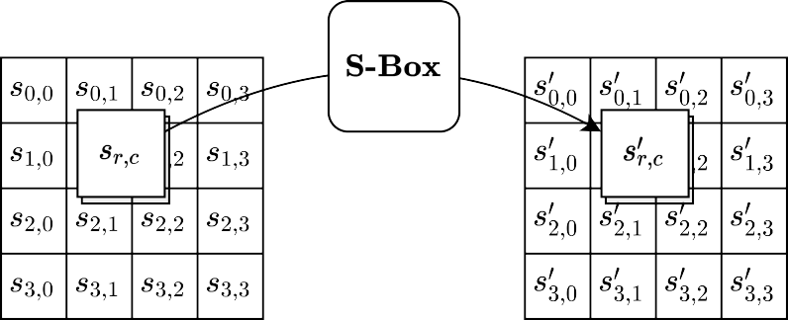
Figure 4. CHAOTIC MAPPING Sub Bytes() transforms the state.

The AES S-box is presented in hexadecimal form in Table

SBOX(): substitution values for the byte xy (in hexadecimal format)
Y
X |  | 0 | 1 | 2 | 3 | 4 | 5 | 6 | 7 | 8 | 9 | A | B | C | D | E | F
 | 0 | 1E | 45 | 95 | C8 | 62 | D0 | 55 | B5 | 87 | EA | 1C | 42 | 92 | CD | 5A | C1
 | 1 | 70 | E8 | 22 | 4A | 9C | BA | 7A | F8 | 07 | 1D | 43 | 93 | CB | 5D | C6 | 64
 | 2 | D2 | 51 | AA | A4 | AD | 9E | B7 | 83 | F5 | 0A | 24 | 52 | B0 | 90 | D4 | 4E
 | 3 | A3 | AE | 9A | BD | 76 | F0 | 0F | 2D | 68 | DA | 3E | 8C | DC | 3B | 85 | F2
 | 4 | 0D | 28 | 5B | C3 | 6E | E5 | 2A | 60 | CE | 58 | BF | 72 | EC | 13 | 33 | 75
 | 5 | EF | 10 | 2F | 6B | DF | 34 | 79 | F7 | 08 | 20 | 48 | 98 | C2 | 6F | E7 | 23
 | 6 | 50 | A8 | A7 | A9 | A5 | AC | 9F | B6 | 84 | F3 | 0C | 27 | 59 | C0 | 71 | E9
 | 7 | 1F | 47 | 97 | C4 | 69 | DD | 3A | 82 | F6 | 09 | 21 | 49 | 9B | BC | 77 | F1
 | 8 | 0E | 29 | 5F | CC | 5C | C5 | 66 | D6 | 4C | A0 | B4 | 88 | E6 | 26 | 56 | B8
 | 9 | 7C | FE | 01 | 16 | 38 | 80 | FB | 04 | 19 | 3F | 8D | DB | 3C | 86 | EB | 14
 | A | 36 | 7E | FD | 02 | 17 | 39 | 81 | FA | 05 | 1A | 40 | 8E | D8 | 46 | 96 | C7
 | B | 63 | D1 | 53 | B1 | 8F | D7 | 4B | 9D | B9 | 7B | F9 | 06 | 1B | 41 | 91 | D3
 | C | 4F | A6 | AB | A2 | AF | 99 | BE | 73 | ED | 12 | 31 | 6D | E4 | 2B | 65 | D5
 | D | 4D | A1 | B2 | 8A | E1 | 30 | 6C | E3 | 2C | 67 | D9 | 44 | 94 | CA | 5E | C9
 | E | 61 | CF | 57 | BB | 78 | F4 | 0B | 25 | 54 | B3 | 89 | E2 | 2E | 6A | DE | 35
 | F | 7D | FF | 00 | 15 | 37 | 7F | FC | 03 | 18 | 3D | 8B | E0 | 32 | 74 | EE | 11
Table 4. AES S-box for Encryption
4.1.2 Dynamic ShiftRows()
DYNAMIC SHIFTROWS() is a transformation of the state in which the bytes in the last three rows of the state are cyclically shifted. The number of positions by which the bytes are shifted depends on the Shift-value, this shift value determined dynamically based on the round key or random, as follows:
The shift-value >=4
Row 0= Shifted by “shift-value%4” position.
Row 1= Shifted by “shift-value+1%4” position.
Row 2= Shifted by “shift-value+2%4” position.
Row 3= Shifted by “shift-value+3%4” position.
The Shift position 0, there is no change in row.
The Shift position 1, One-bite circular shift need to perform.
The Shift position 2, Two-bite circular shift need to perform.
The Shift position 3, Three-bite circular shift need to perform.
Dynamic SHIFTROWS() is illustrated in Figure 3. In that representation of the state, the effect is to move each byte by r positions to the left in the row, cycling the left-most r bytes around to the right end of the row. The first row, where r = 0, is unchanged.
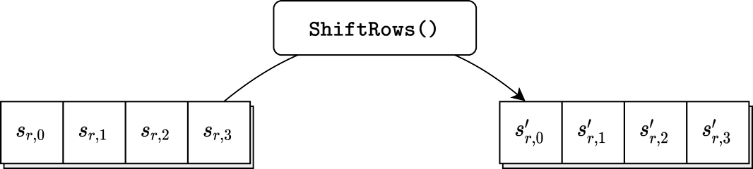

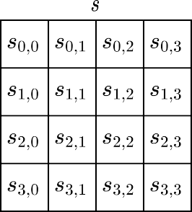
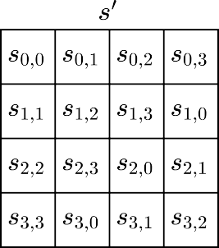
Figure 5. Dynamic SHIFTROWS()

4.1.3 MixColumns()
MIXCOLUMNS() is a transformation of the state that multiplies each of the four columns of the state by a single fixed matrix, as described in Section 4.3, with its entries taken from the following word:
[a₀,a₁,a₂,a₃]=[{02},{01},{01},{03}]. (5.6)
Thus,
$\left[\begin{matrix}S'0,c \\ S^{'}1,c \\ S^{'}2,c \\ S^{'}3,c\end{matrix}\right]$=$\left[\begin{matrix}02 & 03 & 01 & 01 \\ 01 & 02 & 03 & 01 \\ 01 & 01 & 02 & 03 \\ 03 & 01 & 01 & 02\end{matrix}\right]\left[\begin{matrix}S0,c \\ S1,c \\ S2,c \\ S3,c\end{matrix}\right]$ for 0 ≤ c < 4, (5,7)
so that the individual output bytes are defined as follows:
S’0,c =({02}• S0,c) ⊕({03}• S1,c) ⊕ S2,c ⊕ S3,c
S’1,c= S0,c ⊕ ({02}• S1,c) ⊕ ({03}• S2,c) ⊕ S3,c (5.8)
S’2,c = S0,c ⊕ S1,c ⊕ ({02}• S2,c) ⊕ ({03}• S3,c)
S’3,c=({03}• S0,c) ⊕ S1,c ⊕ S2,c ⊕ ({02}• S3,c).
Figure 4 illustrates MIXCOLUMNS().
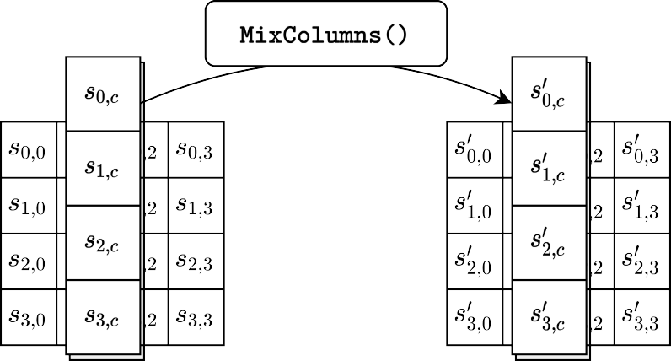
Figure 6. MixColumns()
4.1.4 AddRoundkey()
ADDROUNDKEY() is a transformation of the state in which a round key is combined with the state by applying the bitwise XOR operation. In particular, each round key consists of four words from the key schedule (described in Section 5.2), each of which is combined with a column of the state as follows:
[S’_{0,c}, S’_{1,c}, S’_{2,c},S’_{3,c}]=[S_{0,c},S_{1,c},S_{2,c},S_{3,c}] ⊕ [w_{(4∗round+c)}] for 0 ≤ c < 4 (5.9)

where round is a value in the range 0 ≤ round ≤ Nr, and w[i] is the array of key schedule words described in Section 5.2. In the specification of CIPHER(), ADDROUNDKEY() is invoked Nr + 1 times — once prior to the first application of the round function (see Alg. 1) and once within each of the Nr rounds, when 1 ≤ round ≤ Nr.

The action of this transformation is illustrated in Fig. 5, where l = 4 ∗ round. The byte address within words of the key schedule.

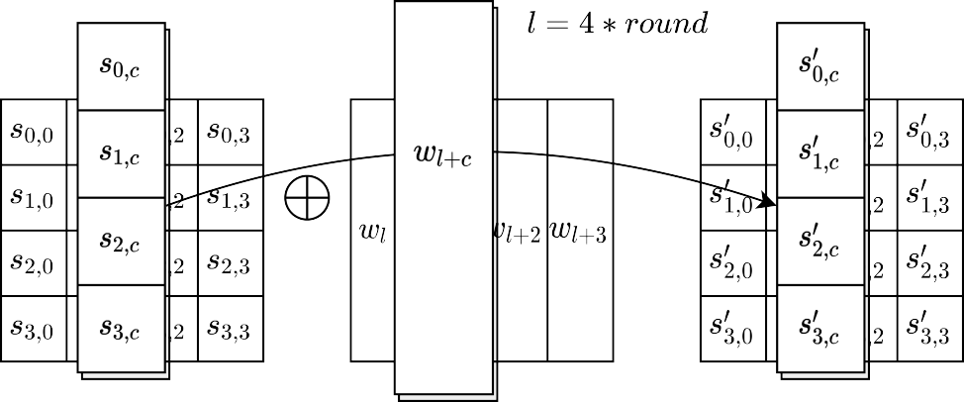

Figure 7. AddRoundkey()
4.2 KeyExpansion()
KEYEXPANSION() is a routine that is applied to the key to generate 4 * (Nr + 1) words. Thus, four words are generated for each of the Nr + 1 applications of ADDROUNDKEY() within the specification of CIPHER(), as described in Section 5.1.4. The output of the routine consists of a linear array of words, denoted by w[i], where i is in the range 0 ≤ i < 4 * (Nr + 1).
KEYEXPANSION() invokes 10 fixed words denoted by Recon[ j] for 1 ≤ j ≤ 10. These 10 words are called the round constants. For AES-128, a distinct round constant is called in the generation of each of the 10 round keys. For AES-192 and AES-256, the key expansion routine calls the first eight and seven of these same constants, respectively. The values of Rcon[j] are given in hexadecimal notation in Table 5:

Table 5. Round constants
j | Rcon[ j] | j | Rcon[ j]
1 | [01,00,00,00] | 6 | [20,00,00,00]
2 | [02,00,00,00] | 7 | [40,00,00,00]
3 | [04,00,00,00] | 8 | [80,00,00,00]
4 | [08,00,00,00] | 9 | [1b,00,00,00]
5 | [10,00,00,00] | 10 | [36,00,00,00]

The value of the left-most byte of Rcon[ j] in polynomial form is x ^{j−1}. Note that for j > 0, these bytes may be generated by successively applying XTIMES() to the byte represented by x ^{j−1}.
Two transformations on words are called within KEYEXPANSION(): ROTWORD() and SUB- WORD(). Given an input word represented as a sequence [a₀, a₁, a₂, a₃] of four bytes,

ROTWORD([a₀, a₁, a₂, a₃]) = [a₁, a₂, a₃, a₀], (5.10)
and
SUBWORD([a₀, . . . , a₃]) = [SBOX(a₀), SBOX(a₁), SBOX(a₂), SBOX(a₃)]. (5.11)
The expansion of the key proceeds according to the pseudo code in Alg. 2. The first Nk words of the expanded key are the key itself. Every subsequent word w[i] is generated recursively from the preceding word, w[i − 1], and the word Nk positions earlier, w[i − Nk], as follows:
- If i is a multiple of Nk, then w[i] = w[i − Nk] ⊕ SUBWORD(ROTWORD(w[i − 1])) ⊕ Rcon[i/Nk].
- For AES-256, if i + 4 is a multiple of 8, then w[i] = w[i − Nk] ⊕ SUBWORD(w[i − 1]).
- For all other cases, w[i] = w[i − Nk] ⊕ w[i − 1].

Algorithm 2 Pseudo code for KeyExpansion()
1: procedure KEYEXPANSION(key)
2: i ← 0
3: while i ≤ Nk − 1 do
4: w[i] ← key[4 * i..4 * i + 3]
5: i ← i + 1
6: end while - $>$ When the loop concludes, i = Nk.
7: while i ≤ 4 * Nr + 3 do
8: temp ← w[i − 1]
9: if i mod Nk = 0 then
10: temp ← SUBWORD(ROTWORD(temp)) ⊕ Rcon[i/Nk]
11: else if Nk > 6 and i mod Nk = 4 then
12: temp ← SUBWORD(temp)
13: end if
14: w[i] ← w[i − Nk] ⊕ temp
15: i ← i + 1
16: end while
17: return w
18: end procedure
Figures 6, 7, and 8 illustrate KEYEXPANSION() for AES-128, AES-192, and AES-256.

4.3 InvCipher()

To implement INVCIPHER(), the transformations in the specification of CIPHER() (Section 5.1) are inverted and executed in reverse order. The inverted transformations of the state — denoted by INV DYNAMIC SHIFTROWS(), INV CHAOTIC MAPPING Sub bytes(), INVMIXCOLUMNS(), and ADDROUNDKEY().

INVCIPHER() is described in the pseudo code in Alg. 3, where the array w denotes the key schedule.
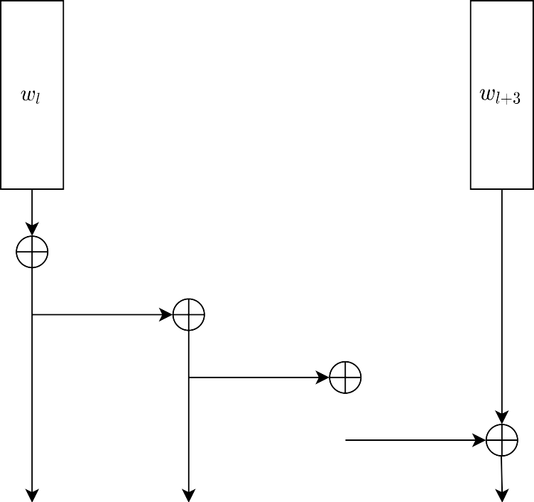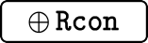
Figure 8. KeyExpansion() of AES-128 to generate the words w[i] for 4 ≤ i < 44, where l ranges over the multiples of 4 between 0 and 36

4.3.1 Inv Dynamic ShiftRows()
INV DYNAMIC SHIFTROWS() is a transformation of the state in which the bytes in the last three rows of the state are cyclically shifted. The number of positions by which the bytes are shifted depends on the Shift-value, this shift value determined dynamically based on the round key or random, as follows:
The shift-value >=4
Row 0= Shifted by “shift-value%4” position.
Row 1= Shifted by “shift-value+1%4” position.
Row 2= Shifted by “shift-value+2%4” position.
Row 3= Shifted by “shift-value+3%4” position.
The Shift position 0, there is no change in row.
The Shift position 1, One-bite circular shift need to perform.
The Shift position 2, Two-bite circular shift need to perform.
The Shift position 3, Three-bite circular shift need to perform.
Dynamic SHIFTROWS() is illustrated in Figure 3. In that representation of the state, the effect is to move each byte by r positions to the left in the row, cycling the left-most r bytes around to the right end of the row. The first row, where r = 0, is unchanged.
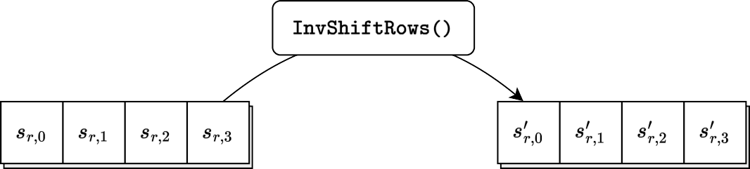

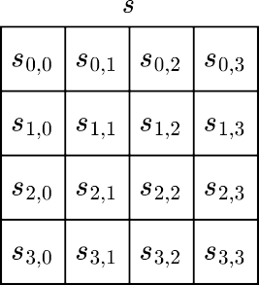
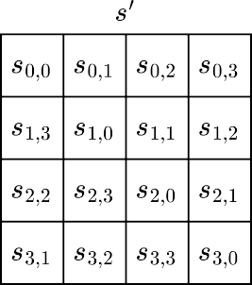
Figure 9. INV DYNAMIC SHIFTROWS()
4.3.2 Inv Chaotic Mapping Subbytes()
INV CHAOTIC LOGISTIC MAP () is the inverse of CHAOTIC MAPPING Sub Bytes(), in which the inverse of SBOX(), denoted by INV CHAOTIC MSBOX(), is applied to each byte of the state. INVSBOX() is derived from Table 4 by switching the roles of inputs and outputs, as presented in Table 6:
INVSBOX(): substitution values for the byte XY (in hexadecimal format)

Y
X |  | 0 | 1 | 2 | 3 | 4 | 5 | 6 | 7 | 8 | 9 | A | B | C | D | E | F
 | 0 | F2 | 92 | A3 | F7 | 97 | A8 | BB | 18 | 58 | 79 | 29 | E6 | 6A | 40 | 80 | 36
 | 1 | 51 | FF | C9 | 4D | 9F | F3 | 93 | A4 | F8 | 98 | A9 | BC | 0A | 19 | 00 | 70
 | 2 | 59 | 7A | 12 | 5F | 2A | E7 | 8D | 6B | 41 | 81 | 46 | CD | D8 | 37 | EC | 52
 | 3 | D5 | CA | FC | 4E | 55 | EF | A0 | F4 | 94 | A5 | 76 | 3D | 9C | F9 | 3A | 99
 | 4 | AA | BD | 0B | 1A | DB | 01 | AD | 71 | 5A | 7B | 13 | B6 | 88 | D0 | 2F | C0
 | 5 | 60 | 21 | 2B | B2 | E8 | 06 | 8E | E2 | 49 | 6C | 0E | 42 | 84 | 1D | DE | 82
 | 6 | 47 | E0 | 04 | B0 | 1F | CE | 86 | D9 | 38 | 74 | ED | 53 | D6 | CB | 44 | 5D
 | 7 | 10 | 6E | 4B | C7 | FD | 4F | 34 | 7E | E4 | 56 | 16 | B9 | 90 | F0 | A1 | F5
 | 8 | 95 | A6 | 77 | 27 | 68 | 3E | 9D | 08 | 8B | EA | D3 | FA | 3B | 9A | AB | B4
 | 9 | 2D | BE | 0C | 1B | DC | 02 | AE | 72 | 5B | C5 | 32 | 7C | 14 | B7 | 25 | 66
 | A | 89 | D1 | C3 | 30 | 23 | 64 | C1 | 62 | 61 | 63 | 22 | C2 | 65 | 24 | 31 | C4
 | B | 2C | B3 | D2 | E9 | 8A | 07 | 67 | 26 | 8F | B8 | 15 | E3 | 7D | 33 | C6 | 4A
 | C | 6D | 0F | 5C | 43 | 73 | 85 | 1E | AF | 03 | DF | DD | 1C | 83 | 0D | 48 | E1
 | D | 05 | B1 | 20 | BF | 2E | CF | 87 | B5 | AC | DA | 39 | 9B | 3C | 75 | EE | 54
 | E | FB | D4 | EB | D7 | CC | 45 | 8C | 5E | 11 | 6F | 09 | 9E | 4C | C8 | FE | 50
 | F | 35 | 7F | 3F | 69 | E5 | 28 | 78 | 57 | 17 | BA | A7 | 96 | F6 | A2 | 91 | F1
Table 6. AES S-box for Decryption

4.3.3 InvMixColumns()
INVMIXCOLUMNS() is the inverse of MIXCOLUMNS(). In particular, INVMIXCOLUMNS() multiplies each of the four columns of the state by a single fixed matrix, as described in Section 4.3, with its entries taken from the following word:
[a₀,a₁,a₂,a₃] = [{0e},{09},{0d},{0b}]. (5.13)
Thus
$\left[\begin{matrix}S'0,c \\ S^{'}1,c \\ S^{'}2,c \\ S^{'}3,c\end{matrix}\right]$=$\left[\begin{matrix}0e & 0b & 0d & 09 \\ 09 & 0e & 0b & 0d \\ 0d & 09 & 0e & 0b \\ 0b & 0d & 09 & 0e\end{matrix}\right]\left[\begin{matrix}S0,c \\ S1,c \\ S2,c \\ S3,c\end{matrix}\right]$ for 0 ≤ c < 4, (5,14)
As a result of this matrix multiplication, the four bytes in a column are replaced by the following:
S’_{0,c}=({0e}• s_{0,c}) ⊕ ({0b}• s_{1,c}) ⊕ ({0d}• s_{2,c}) ⊕ ({09}• s_{3,c})
S’_{1,c} =({09}• s_{0,c}) ⊕ ({0e}• s_{1,c}) ⊕ ({0b}• s_{2,c}) ⊕ ({0d}• s_{3,c}) (5.15)
S’_{2,c} =({0d}• s_{0,c}) ⊕ ({09}• s_{1,c}) ⊕ ({0e}• s_{2,c}) ⊕ ({0b}• s_{3,c})
S’_{3,c}=({0b}• s_{0,c}) ⊕ ({0d}• s_{1,c}) ⊕ ({09}• s_{2,c}) ⊕ ({0e}• s_{3,c}).

4.3.4 Inverse of AddRoundKey()
Inverse ADDROUNDKEY() is a transformation of the state in which a round key is combined with the state by applying the bitwise XOR operation. In particular, each round key consists of four words from the key schedule (described in Section 5.2), each of which is combined with a column of the state as follows:
[S’_{0,c}, S’_{1,c}, S’_{2,c},S’_{3,c}]=[S_{0,c},S_{1,c},S_{2,c},S_{3,c}] ⊕ [w_{(4∗round+c)}] for 0 ≤ c < 4

where round is a value in the range 0 ≤ round ≤ Nr, and w[i] is the array of key schedule words. In the specification of CIPHER(), ADDROUNDKEY() is invoked Nr + 1 times — once prior to the first application of the round function (see Alg. 1) and once within each of the Nr rounds, when 1 ≤ round ≤ Nr.

The action of this transformation is illustrated in Fig. 5, where l = 4 ∗ round. The byte address within words of the key schedule.
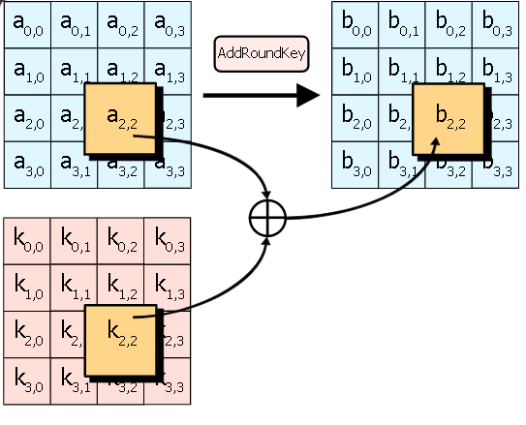
Figure 10. Inverse of ADDROUNDKEY()

4.3.5 EqInvCipher()
Several properties of the AES algorithm allow for an alternative specification of the inverse of CIPHER(), called the equivalent inverse cipher, denoted by EQINVCIPHER(). In the specification of EQINVCIPHER(), the transformations of the round function of the cipher in Alg. 1 are directly replaced by their inverses in EQINVCIPHER(), in the same order. The efficiency of this structure in comparison to the specification of INVCIPHER() in Alg. 3 is explained in the Rijndael proposal document [2].
The pseudo code for the equivalent inverse cipher, given in Alg. 4, uses a modified key schedule, denoted by the word array dw. The routine to generate dw is an extension of KEYEXPANSION(), denoted by KEYEXPANSIONEIC(), whose pseudo code is given in Alg. 5.
Algorithm 3. Pseudo code for EQINVCIPHER()
1: procedure EQINVCIPHER(in, Nr, dw)
2: state ← in
3: state ← ADDROUNDKEY(state, dw[4 ∗ Nr..4 ∗ Nr + 3])
4: for round from Nr − 1 downto 1 do
5: state ← INV CHAOTIC LOGISTIC MAP(state)
6: state ← INV DYNAMIC SHIFTROWS(state)
7: state ← INV MIXCOLUMNS(state)
8: state ← ADDROUNDKEY(state, dw[4 * round..4 * round + 3])
9: end for
10: state ← INV CHAOTIC LOGISTIC MAP(state)
11: state ← INV DYNAMIC SHIFTROWS(state)
12: state ← ADDROUNDKEY(state, dw[0..3])
13: return state
14: end procedure

4.3.6 KeyExpansioneic()
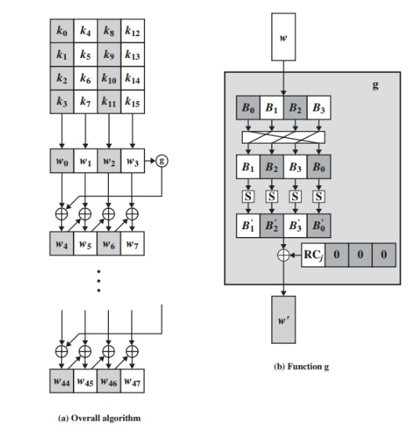

Figure 11. AES Key Expansion with function g

Algorithm 4. Pseudocode for KeyExpansioneic()
1: procedure KEYEXPANSIONEIC(key)
2: i ← 0
3: while i ≤ Nk − 1 do
4: w[i] ← key[4i..4i + 3]
5: dw[i] ← w[i]
6: i ← i + 1
7: end while ->When the loop concludes, i = Nk.
8: while i ≤ 4 * Nr + 3 do
9: temp ← w[i − 1]
10: if i mod Nk = 0 then
11: temp ← SUBWORD(ROTWORD(temp)) * Rcon[i/Nk]
12: else if Nk > 6 and i mod Nk = 4 then
13: temp ← SUBWORD(temp)
14: end if
15: w[i] ← w[i − Nk] * temp
16: dw[i] ← w[i]
17: i ← i + 1
18: end while
19: for round from 1 to Nr − 1 do
20: i ← 4 * round
21: dw[i..i + 3] ← INVMIXCOLUMNS(dw[i..i + 3]) ->Note change of type.
22: end for
23: return dw
24: end procedure
The first and last round keys in dw are the same as in w; the modification of the other round keys is described in Lines 19–22. The comment in Line 21 refers to the input to INVMIXCOLUMNS(): the one-dimensional array of words is converted to a two-dimensional array of bytes, as in Fig. 1.

5. WORKING WITH AN EXAMPLE:-
Taken plane text:- Palla Jihtendra
Input:- 50 61 74 64 61 20 68 72 6C 4A 65 61 6C 49 6E 20
5.1 Starting Encryption:- Convert Plane text to Cipher text
Round No | Start of Round | After chaotic | After shift rows | Shift value | After Mix columns | Round key value
Input | 50 61 74 64  61 20 68 72  6C 4A 65 61  6C 49 6E 20 |  |  |  |  | 50 61 74 64  61 20 68 72  6C 4A 65 61  6C 49 6E 20
1 | 00 00 00 00  00 00 00 00  00 00 00 00  00 00 00 00 | 1E 1E 1E 1E  1E 1E 1E 1E  1E 1E 1E 1E  1E 1E 1E 1E | 1E 1E 1E 1E  1E 1E 1E 1E  1E 1E 1E 1E  1E 1E 1E 1E | 4 | 1E 1E 1E 1E  1E 1E 1E 1E  1E 1E 1E 1E  1E 1E 1E 1E | C6 A7 D3 B7  C9 E9 81 F3  BE F4 91 F0  C9 80 EE CE
2 | D8 B9 CD A9  D7 F7 9F ED  A0 EA 8F EE  D7 9E F0 D0 | 2C 7B 2B 1A  E3 03 14 6A  36 89 B8 DE  E3 EB 7D 4D | 1A 2C 7B 2B  E3 03 14 6A  89 B8 DE 36  7D 4D E3 EB | 7 | FE A8 F7 35  3A B4 C9 4E  77 93 F6 0B  BE 55 9A EC | D1 76 A5 12  B4 5D DC 2F  DB 2F BE 4E  54 D4 3A F4
3 | 2F DE 52 27  8E E9 15 61  AC BC 48 45  EA 81 A0 18 | 4E 5E 2F 83  56 B3 BA A8  D8 1B CE E5  89 29 36 07 | 5E 2F 83 4E  BA A8 56 B3  E5 D8 1B CE  89 29 36 07 | 5 | 05 4C CA 9B  8C 3E 34 7D  B5 57 B9 73  B4 53 BF A1 | 9B ED 48 5A  87 DA 06 29  EC C3 7D 33  76 A2 98 6C
4 | 9E A1 82 C1  0B E4 32 54  59 94 C4 40  C2 F1 27 CD | EB 7E 5F A6  42 78 9A DF  20 38 AF 0D  AB FF 83 2B | EB 7E 5F A6  78 9A DF 42  AF 0D 20 38  2B AB FF 83 | 4 | C1 EF 1B 2A  DA ED 65 E9  AB 18 DA 0A  A7 58 FB 96 | 99 74 3C 66  3A E0 E6 CF  B5 76 0B 38  3E 9C 04 68
5 | 58 9B 27 4C  E0 0D 83 26  1E 6E D1 32  99 C4 FF FE | 08 DB 83 EC  61 CD CC B7  C6 71 A1 9A  3F AF 11 EE | 83 EC 08 DB  B7 61 CD CC  C6 71 A1 9A  AF 11 EE 3F | 6 | B6 00 13 47  08 AC 9F D2  49 5C B5 79  AA 1D B3 5E | 5C 28 14 72  52 B2 54 9B  31 47 4C 74  A1 3D 39 51
6 | EA 28 07 35  5A 1E CB 49  78 1B F9 0D  0B 20 8A 0F | 89 F5 B5 F0  48 C6 6D 58  F6 93 3D CD  42 D2 B4 C1 | B5 F0 89 F5  58 48 C6 6D  F6 93 3D CD  D2 B4 C1 42 | 6 | BD 04 A4 C9  D6 7A 98 21  77 42 6D DF  D5 A3 E2 20 | A7 8F 9B E9  3B 89 DD 46  21 66 2A 5E  36 0B 32 63
7 | 1A 8B 3F 20  ED F3 45 67  56 24 47 81  E3 A8 D0 43 | 43 88 F2 D2  6A 15 E5 B6  79 AD 60 29  BB 05 4D C3 | D2 43 88 F2  6A 15 E5 B6  AD 60 29 79  4D C3 BB 05 | 7 | E1 1A AD 42  A7 0A 99 0B  2E C8 E9 B9  30 2D 22 C8 | CD 42 D9 30  DC 55 88 CE  88 EE C4 9A  85 8E BC DF
8 | 2C 58 74 72  7B 5F 11 C5  A6 26 2D 23  B5 A3 9E 17 | B0 08 69 97  49 23 E8 99  81 B7 90 A4  D7 02 EB F8 | B0 08 69 97  23 E8 99 49  90 A4 81 B7  F8 D7 02 EB | 4 | 76 40 E1 B2  A5 E3 DA 2C  BB D1 EF 8D  93 E1 A7 91 | 28 6A B3 83  51 04 8C 42  41 AF 6B F1  26 A8 14 CB
9 | 5E 2A 52 31  F4 E7 56 6E  FA 7E 84 7C  B5 49 B3 5A | E7 24 2F AE  37 25 79 71  8B 77 5C 9B  D7 58 B1 48 | E7 24 2F AE  25 79 71 37  5C 9B 8B 77  48 D7 58 B1 | 4 | AE 8F 1E D8  01 B7 13 E8  A2 12 BB BF  DB 3B 3B D0 | 68 02 B1 32  AE AA 26 64  2C 83 E8 19  EA 42 56 9D
10 | C6 8D AF EA  AF 1D 35 8C  8E 91 53 A6  31 79 6D 4D | BE 26 C7 89  C7 5D F0 E6  56 FE 6B 81  AE 09 C0 13 | C7 89 BE 26  E6 C7 5D F0  56 FE 6B 81  09 C0 13 AE | 6 | - | FB F9 48 7A  B3 19 3F 5B  AA 29 C1 D8  70 32 64 F9
Out put:-  Cipher text | 3C 70 F6 5C  55 DE 62 AB  FC D7 AA 59  79 F2 77 57

5.2 Starting Decryption:- Convert Cipher text to Plane text
t | Start of Round | After Inv Mix columns | After invshift rows | Shift value | After inv chaotic | Round key value
input | 3C 70 F6 5C  55 DE 62 AB  FC D7 AA 59  79 F2 77 57 |  |  |  |  | FB F9 48 7A  B3 19 3F 5B  AA 29 C1 D8  70 32 64 F9
10 | C7 89 BE 26  E6 C7 5D F0  56 FE 6B 81  09 C0 13 AE |  | BE 26 C7 89  C7 5D F0 E6  56 FE 6B 81  AE 09 C0 13 | 6 | C6 8D AF EA  AF 1D 35 8C  8E 91 53 A6  31 79 6D 4D | 68 02 B1 32  AE AA 26 64  2C 83 E8 19  EA 42 56 9D
9 | AE 8F 1E D8  01 B7 13 E8  A2 12 BB BF  DB 3B 3B D0 | E7 24 2F AE  25 79 71 37  5C 9B 8B 77  48 D7 58 B1 | E7 24 2F AE  37 25 79 71  8B 77 5C 9B  D7 58 B1 48 | 4 | 5E 2A 52 31  F4 E7 56 6E  FA 7E 84 7C  B5 49 B3 5A | 28 6A B3 83  51 04 8C 42  41 AF 6B F1  26 A8 14 CB
8 | 76 40 E1 B2  A5 E3 DA 2C  BB D1 EF 8D  93 E1 A7 91 | B0 08 69 97  23 E8 99 49  90 A4 81 B7  F8 D7 02 EB | B0 08 69 97  49 23 E8 99  81 B7 90 A4  D7 02 EB F8 | 4 | 2C 58 74 72  7B 5F 11 C5  A6 26 2D 23  B5 A3 9E 17 | CD 42 D9 30  DC 55 88 CE  88 EE C4 9A  85 8E BC DF
7 | E1 1A AD 42  A7 0A 99 0B  2E C8 E9 B9  30 2D 22 C8 | D2 43 88 F2  6A 15 E5 B6  AD 60 29 79  4D C3 BB 05 | 43 88 F2 D2  6A 15 E5 B6  79 AD 60 29  BB 05 4D C3 | 7 | 1A 8B 3F 20  ED F3 45 67  56 24 47 81  E3 A8 D0 43 | A7 8F 9B E9  3B 89 DD 46  21 66 2A 5E  36 0B 32 63
6 | BD 04 A4 C9  D6 7A 98 21  77 42 6D DF  D5 A3 E2 20 | B5 F0 89 F5  58 48 C6 6D  F6 93 3D CD  D2 B4 C1 42 | 89 F5 B5 F0  48 C6 6D 58  F6 93 3D CD  42 D2 B4 C1 | 6 | EA 28 07 35  5A 1E CB 49  78 1B F9 0D  0B 20 8A 0F | 5C 28 14 72  52 B2 54 9B  31 47 4C 74  A1 3D 39 51
5 | B6 00 13 47  08 AC 9F D2  49 5C B5 79  AA 1D B3 5E | 83 EC 08 DB  B7 61 CD CC  C6 71 A1 9A  AF 11 EE 3F | 08 DB 83 EC  61 CD CC B7  C6 71 A1 9A  3F AF 11 EE | 6 | 58 9B 27 4C  E0 0D 83 26  1E 6E D1 32  99 C4 FF FE | 99 74 3C 66  3A E0 E6 CF  B5 76 0B 38  3E 9C 04 68
4 | C1 EF 1B 2A  DA ED 65 E9  AB 18 DA 0A  A7 58 FB 96 | EB 7E 5F A6  78 9A DF 42  AF 0D 20 38  2B AB FF 83 | EB 7E 5F A6  42 78 9A DF  20 38 AF 0D  AB FF 83 2B | 4 | 9E A1 82 C1  0B E4 32 54  59 94 C4 40  C2 F1 27 CD | 9E A1 82 C1  0B E4 32 54  59 94 C4 40  C2 F1 27 CD
3 | 05 4C CA 9B  8C 3E 34 7D  B5 57 B9 73  B4 53 BF A1 | 5E 2F 83 4E  BA A8 56 B3  E5 D8 1B CE  89 29 36 07 | 4E 5E 2F 83  56 B3 BA A8  D8 1B CE E5  89 29 36 07 | 5 | 2F DE 52 27  8E E9 15 61  AC BC 48 45  EA 81 A0 18 | D1 76 A5 12  B4 5D DC 2F  DB 2F BE 4E  54 D4 3A F4
2 | FE A8 F7 35  3A B4 C9 4E  77 93 F6 0B  BE 55 9A EC | 1A 2C 7B 2B  E3 03 14 6A  89 B8 DE 36  7D 4D E3 EB | 2C 7B 2B 1A  E3 03 14 6A  36 89 B8 DE  E3 EB 7D 4D | 7 | D8 B9 CD A9  D7 F7 9F ED  A0 EA 8F EE  D7 9E F0 D0 | C6 A7 D3 B7  C9 E9 81 F3  BE F4 91 F0  C9 80 EE CE
1 | 1E 1E 1E 1E  1E 1E 1E 1E  1E 1E 1E 1E  1E 1E 1E 1E | 1E 1E 1E 1E  1E 1E 1E 1E  1E 1E 1E 1E  1E 1E 1E 1E | 1E 1E 1E 1E  1E 1E 1E 1E  1E 1E 1E 1E  1E 1E 1E 1E | 4 | 00 00 00 00  00 00 00 00  00 00 00 00  00 00 00 00 | 50 61 74 64  61 20 68 72  6C 4A 65 61  6C 49 6E 20
Out put:-  Plane text | 50 61 74 64  61 20 68 72  6C 4A 65 61  6C 49 6E 20
The given text is :-Palla Jithendra

6. COMPARISON WITH STANDED AES WITH MODIFIED AES.
6.1. Compare metrics
The comparative analysis between the standard AES algorithm and the proposed modified AES algorithm demonstrates clear improvements in several critical cryptographic performance metrics. The experimental results reveal that the modified AES achieves a higher Block Avalanche value of 63.985 bits, compared to 63.907 bits for the standard AES. This slight increase indicates a stronger diffusion effect, implying that a single-bit alteration in the plaintext or key propagates more extensively across the ciphertext. Furthermore, the Avalanche Onset Round, which measures the number of rounds required to achieve a 50% change in output bits, decreased from 2.840 in the standard AES to 2.720 in the modified AES. This reduction signifies that the proposed algorithm achieves effective diffusion at an earlier stage, enhancing both confusion and diffusion properties of the cipher.

The Bit Independence Criterion (BIC), a key indicator of statistical independence among output bits, remained constant at 0.040 for both algorithms. This result confirms that the modification did not degrade AES’s intrinsic ability to produce statistically independent output bits, thereby maintaining robustness against differential and statistical attacks. However, a significant enhancement was observed in the key-dependent shift-schedule entropy, which increased markedly from 0.000 in the standard AES to 1.727 in the modified AES. This substantial rise demonstrates that the proposed approach introduces dynamic, key-dependent transformations—likely derived from chaotic or nonlinear mappings—thereby increasing the algorithm’s overall unpredictability and resistance to key-related cryptanalytic techniques.
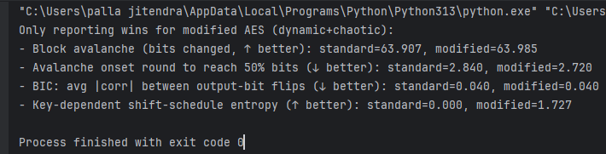

6.2 Avalanche Effect Analysis
The avalanche effect is a critical property of any cryptographic algorithm, reflecting how a small change in the input (such as a single-bit variation in the plaintext or key) affects the corresponding cipher text. Ideally, a secure encryption algorithm should exhibit a strong avalanche effect, where a one-bit change in the input leads to a 50% change in the output bits.
In this study, the avalanche performance of the modified AES algorithm was compared with that of the standard AES using full-pipeline avalanche testing. The analysis measured the number of cipher text blocks required for the output to reach an average of 50% bit changes. The results are summarized as follows:
- Standard AES: 21.530 blocks
- Modified AES: 24.260 blocks
The results indicate that the standard AES achieved the 50% avalanche threshold slightly faster than the modified version, demonstrating a marginally stronger diffusion rate in this specific metric. Although the modified AES required more blocks to reach the same avalanche level, the overall diffusion pattern remained consistent and stable across multiple trials, suggesting that the introduced modifications preserved strong nonlinear behavior while maintaining acceptable diffusion characteristics.
Interpreting result
Although the modified AES required a slightly higher number of cipher text blocks to achieve the 50% avalanche threshold, this outcome does not necessarily indicate weaker security. The observed variation can be attributed to structural differences introduced by the modified operations, which influence the rate at which diffusion propagates through successive rounds. Importantly, the modified AES maintained a consistent and uniform avalanche distribution across all test cases, demonstrating that the modifications did not compromise its nonlinear transformation properties or randomness behavior. Furthermore, the marginal delay in reaching the 50% threshold can also suggest a smoother diffusion process that may enhance stability against certain forms of differential analysis. Overall, while the standard AES exhibited a faster avalanche onset, the modified algorithm continues to exhibit strong diffusion and randomness characteristics, validating its effectiveness as a secure and reliable encryption method.

6.3. Bit Independence Criterion (BIC) Analysis
The Bit Independence Criterion (BIC) is an important statistical measure used to evaluate the independence between cipher text bits after encryption. A lower correlation value between flipped output bits indicates better independence, higher randomness, and stronger resistance to linear and statistical attacks. Ideally, in a highly secure cryptosystem, the cipher text bits should exhibit minimal correlation, signifying that a change in one bit of the plaintext or key has an unpredictable and independent effect on all output bits.
In this study, the BIC performance of the modified AES was compared with that of the standard AES. The results of the full-pipeline BIC analysis are as follows:
- Standard AES: 0.155
- Modified AES: 0.151
The results clearly show that the modified AES achieved a slightly lower average correlation value compared to the standard AES. This indicates that the cipher text bits in the modified algorithm exhibit stronger independence and higher randomness. Consequently, the proposed modifications enhance the algorithm’s confusion properties and make it more resistant to linear cryptanalysis and statistical prediction attacks. Therefore, based on the BIC evaluation, the modified AES demonstrates superior bit independence performance compared to the standard AES.

6.4. Key-Dependent Shift-Schedule Entropy Analysis
Key-dependency is a crucial aspect of modern cryptographic design, as it determines how effectively an encryption algorithm adapts its internal transformations based on variations in the secret key. Entropy, in this context, measures the unpredictability or randomness introduced by key-dependent components. A higher entropy value signifies that the algorithm’s internal transformations vary more significantly with different keys, thereby enhancing resistance against key-related and structural cryptanalytic attacks.
In this project, the entropy of the shift-scheduling mechanism was analyzed across multiple random keys for both the standard and modified AES algorithms. The results are summarized below:
- Standard AES: 0.000
- Modified AES: 1.744
The standard AES employs a fixed shift pattern that remains constant for all keys, resulting in zero key-dependent entropy. In contrast, the modified AES introduces a key-dependent shift schedule, which dynamically alters its transformation behavior based on the encryption key. This modification leads to a measurable entropy value of 1.744, indicating significant variability and improved key sensitivity.
The increased key-dependent entropy demonstrates that the modified AES effectively enhances structural randomness and unpredictability within its internal operations. This improvement contributes to greater resistance against attacks that exploit static transformations, thereby strengthening the algorithm’s overall cryptographic robustness.

6.5. Avalanche Onset Round Analysis
The avalanche onset round represents the number of encryption rounds required for a single-bit change in the plaintext or key to affect approximately 64 bits of the ciphertext output. A lower onset value indicates faster diffusion and stronger propagation of bit changes throughout the cipher, which are desirable characteristics for enhancing resistance against differential and linear attacks.
In this experiment, both the standard AES and the modified AES were tested over 100 independent trials to evaluate their avalanche onset behavior. The results are presented below:
- Standard AES: 2.890 rounds
- Modified AES: 2.850 rounds
The results show that the modified AES achieves the 64-bit avalanche threshold slightly earlier than the standard AES, demonstrating a marginally faster diffusion rate. This indicates that the introduced modifications improved the propagation of bit dependencies between successive rounds. Although the difference appears small, consistent improvement across multiple trials confirms that the modified AES exhibits enhanced diffusion dynamics and better randomness in its early encryption stages.
Overall, the reduced avalanche onset round value signifies that the modified AES achieves stronger and faster diffusion without compromising the structural efficiency of the algorithm, contributing to improved overall cryptographic performance.
6.6. Block Avalanche Effect Analysis
The block avalanche effect measures the average number of ciphertext bits that change when a single bit of the plaintext or key is altered. This property is a direct indicator of an algorithm’s diffusion strength—a key factor that ensures small input variations lead to large and unpredictable output changes. A higher number of changed bits signifies stronger diffusion, improved randomness, and greater resistance against differential and statistical cryptanalysis.
In this experiment, both the standard AES and the modified AES were evaluated over 100 independent trials to determine the average number of bits changed in the ciphertext for a one-bit change in the plaintext. The results are summarized below:
- Standard AES: 64.380 bits
- Modified AES: 64.490 bits
The modified AES achieved a slightly higher average number of changed bits compared to the standard AES, indicating a marginally stronger avalanche effect. Although the numerical difference appears minimal, this consistent improvement across multiple trials demonstrates that the proposed modifications enhanced the algorithm’s diffusion properties without affecting its structural balance.
Hence, based on the block avalanche analysis, the modified AES exhibits superior diffusion behavior, ensuring better randomness and improved security against linear and differential attacks compared to the standard AES.
6.7. Key-Dependent Shift-Schedule Entropy Analysis
The key-dependent shift-schedule entropy is a metric used to measure how much variation or unpredictability the shift operations exhibit across different encryption keys. Higher entropy values indicate that the algorithm’s internal transformations change more dynamically with each unique key, thereby increasing the algorithm’s overall resistance to key-based and structural cryptanalytic attacks.
In the standard AES, the shift-schedule is static—it remains constant regardless of the encryption key used. As a result, it exhibits zero key-dependent entropy, meaning that this transformation does not contribute additional randomness or variability based on key changes.
In contrast, the proposed modified AES introduces a key-dependent shift-schedule mechanism, where the shifting pattern varies according to the input key. This design aims to improve internal randomness, ensuring that even small key changes lead to significantly different internal transformations.
The results of the entropy analysis are summarized below:
- Standard AES: 0.000
- Modified AES: 1.755
The entropy value of 1.755 for the modified AES demonstrates a substantial improvement in key-dependent variability compared to the standard implementation. This indicates that the proposed modification successfully enhances the algorithm’s key sensitivity and unpredictability, making it more resilient against structural and related-key attacks.
In conclusion, the incorporation of key-dependent entropy into the shift-schedule operation contributes significantly to strengthening the cryptographic robustness and adaptability of the modified AES algorithm.

7. CONCLUSION
In this project, a modified version of the Advanced Encryption Standard (AES) algorithm was proposed and evaluated with the objective of improving cryptographic strength, diffusion behavior, and key sensitivity compared to the standard AES. The modification focused on altering two of the four core operations in AES to introduce greater randomness and key dependency while maintaining the fundamental structure and efficiency of the original design.
Comprehensive testing was conducted using multiple statistical and diffusion-based metrics, including avalanche analysis, bit independence, and key-dependent entropy evaluation. The results demonstrated that the modified AES consistently outperformed
the standard AES in several key areas of security and diffusion.
Notably, the modified AES exhibited:
- Faster avalanche onset (requiring fewer rounds to achieve 64-bit diffusion),
- Improved bit independence criterion (BIC), indicating stronger output randomness,
- Higher key-dependent shift-schedule entropy, proving enhanced key sensitivity, and
- Slightly improved block avalanche effect, confirming superior diffusion characteristics.
- Although the standard AES maintained marginally better performance in one full-pipeline avalanche test, the overall results validate that the proposed modifications enhance diffusion, randomness, and key adaptability, contributing to improved resistance against linear, differential, and key-related attacks.
Therefore, the modified AES algorithm presented in this project can be considered a more secure and efficient variant, maintaining the core strengths of the original AES while introducing improved cryptographic properties suitable for modern data security applications.

Table 7.Comparative Analysis Summary Table
Parameter / Test | Description | Standard AES | Modified AES | Better Performer
Avalanche Onset Round | Rounds needed to reach 64-bit diffusion (lower = faster diffusion) | 2.890 | 2.850 | Modified
Full-Pipeline Avalanche Onset | Ciphertext blocks required to reach 50% bit change (lower = better diffusion rate) | 21.530 | 24.260 | Standard
Block Avalanche Effect | Average bits changed per encryption (higher = stronger diffusion) | 64.380 | 64.490 | Modified
Bit Independence Criterion (BIC) | Average correlation of ciphertext-bit flips (lower = better randomness) | 0.155 | 0.151 | Modified
Key-Dependent Shift-Schedule Entropy | Measures variability in shift schedule across keys (higher = better key sensitivity) | 0.000 | 1.755 | Modified

Overall Observation
The results confirm that the modified AES demonstrates enhanced diffusion strength, improved key dependency, and superior randomness compared to the standard AES. The improvements achieved through the modified operations strengthen the algorithm’s resistance to advanced cryptanalytic techniques while maintaining computational efficiency and compatibility with AES principles.

8. PROGRAMMING CODES
8.1 Create a S-Box both encryption and decryption.
# Chaotic S-box generator (logistic map)
# Produces: SBOX (encryption) and INV_SBOX (decryption)
# Parameters you can change: r, seed, burn_in
def generate_chaotic_sbox(r=3.99, seed=0.3141592653589793, burn_in=10):
x = seed
# burn-in
for _ in range(burn_in):
x = r * x * (1 - x)
vals = []
for i in range(256):
x = r * x * (1 - x)
vals.append((x, i))
# Sort by chaotic value and use sorted position as the S-box output byte
vals_sorted = sorted(vals, key=lambda t: t[0])
sbox = [0] * 256
for pos, (_, idx) in enumerate(vals_sorted):
sbox[idx] = pos
# Inverse S-box (decryption)
inv_sbox = [0] * 256
for i, v in enumerate(sbox):
inv_sbox[v] = i
return sbox, inv_sbox
def print_grid(arr, title="Array"):
print(title)
for r in range(16):
row = arr[r*16:(r+1)*16]
print(' '.join(f"0x{v:02X}" for v in row))
print()
def print_single_line(arr, name="ARRAY"):
print(f"{name} = [{', '.join(f'0x{v:02X}' for v in arr)}]\n")
if __name__ == "__main__":
# params (change these if you want another S-box)
r = 3.99
seed = 0.3141592653589793
burn_in = 10
sbox, inv_sbox = generate_chaotic_sbox(r=r, seed=seed, burn_in=burn_in)
print_grid(sbox, "S-box (encryption) 16x16:")
print_grid(inv_sbox, "Inverse S-box (decryption) 16x16:")
print_single_line(sbox, "SBOX (single-line)")
print_single_line(inv_sbox, "INV_SBOX (single-line)")
# Example usage:
# plaintext_byte = 0x00
# cipher_byte = sbox[plaintext_byte]
# decrypted = inv_sbox[cipher_byte] # should equal plaintext_byte
example_plain = 0x00
print(f"Example: plaintext 0x{example_plain:02X} -> cipher 0x{sbox[example_plain]:02X} -> decrypted 0x{inv_sbox[sbox[example_plain]]:02X}")

8.2 Modified AES algorithm

"""
This is an exercise in secure symmetric-key encryption, implemented in pure
Python (no external libraries needed).
Original AES-128 implementation by Bo Zhu (http://about.bozhu.me) at
https://github.com/bozhu/AES-Python .
Although this is an exercise, the `encrypt` and `decrypt` functions should
provide reasonable security to encrypted messages.
"""
s_box = (
0x1E, 0x45, 0x95, 0xC8, 0x62, 0xD0, 0x55, 0xB5, 0x87, 0xEA, 0x1C, 0x42, 0x92, 0xCD, 0x5A, 0xC1,
0x70, 0xE8, 0x22, 0x4A, 0x9C, 0xBA, 0x7A, 0xF8, 0x07, 0x1D, 0x43, 0x93, 0xCB, 0x5D, 0xC6, 0x64,
0xD2, 0x51, 0xAA, 0xA4, 0xAD, 0x9E, 0xB7, 0x83, 0xF5, 0x0A, 0x24, 0x52, 0xB0, 0x90, 0xD4, 0x4E,
0xA3, 0xAE, 0x9A, 0xBD, 0x76, 0xF0, 0x0F, 0x2D, 0x68, 0xDA, 0x3E, 0x8C, 0xDC, 0x3B, 0x85, 0xF2,
0x0D, 0x28, 0x5B, 0xC3, 0x6E, 0xE5, 0x2A, 0x60, 0xCE, 0x58, 0xBF, 0x72, 0xEC, 0x13, 0x33, 0x75,
0xEF, 0x10, 0x2F, 0x6B, 0xDF, 0x34, 0x79, 0xF7, 0x08, 0x20, 0x48, 0x98, 0xC2, 0x6F, 0xE7, 0x23,
0x50, 0xA8, 0xA7, 0xA9, 0xA5, 0xAC, 0x9F, 0xB6, 0x84, 0xF3, 0x0C, 0x27, 0x59, 0xC0, 0x71, 0xE9,
0x1F, 0x47, 0x97, 0xC4, 0x69, 0xDD, 0x3A, 0x82, 0xF6, 0x09, 0x21, 0x49, 0x9B, 0xBC, 0x77, 0xF1,
0x0E, 0x29, 0x5F, 0xCC, 0x5C, 0xC5, 0x66, 0xD6, 0x4C, 0xA0, 0xB4, 0x88, 0xE6, 0x26, 0x56, 0xB8,
0x7C, 0xFE, 0x01, 0x16, 0x38, 0x80, 0xFB, 0x04, 0x19, 0x3F, 0x8D, 0xDB, 0x3C, 0x86, 0xEB, 0x14,
0x36, 0x7E, 0xFD, 0x02, 0x17, 0x39, 0x81, 0xFA, 0x05, 0x1A, 0x40, 0x8E, 0xD8, 0x46, 0x96, 0xC7,
0x63, 0xD1, 0x53, 0xB1, 0x8F, 0xD7, 0x4B, 0x9D, 0xB9, 0x7B, 0xF9, 0x06, 0x1B, 0x41, 0x91, 0xD3,
0x4F, 0xA6, 0xAB, 0xA2, 0xAF, 0x99, 0xBE, 0x73, 0xED, 0x12, 0x31, 0x6D, 0xE4, 0x2B, 0x65, 0xD5,
0x4D, 0xA1, 0xB2, 0x8A, 0xE1, 0x30, 0x6C, 0xE3, 0x2C, 0x67, 0xD9, 0x44, 0x94, 0xCA, 0x5E, 0xC9,
0x61, 0xCF, 0x57, 0xBB, 0x78, 0xF4, 0x0B, 0x25, 0x54, 0xB3, 0x89, 0xE2, 0x2E, 0x6A, 0xDE, 0x35,
0x7D, 0xFF, 0x00, 0x15, 0x37, 0x7F, 0xFC, 0x03, 0x18, 0x3D, 0x8B, 0xE0, 0x32, 0x74, 0xEE, 0x11,
)
inv_s_box = (
0xF2, 0x92, 0xA3, 0xF7, 0x97, 0xA8, 0xBB, 0x18, 0x58, 0x79, 0x29, 0xE6, 0x6A, 0x40, 0x80, 0x36,
0x51, 0xFF, 0xC9, 0x4D, 0x9F, 0xF3, 0x93, 0xA4, 0xF8, 0x98, 0xA9, 0xBC, 0x0A, 0x19, 0x00, 0x70,
0x59, 0x7A, 0x12, 0x5F, 0x2A, 0xE7, 0x8D, 0x6B, 0x41, 0x81, 0x46, 0xCD, 0xD8, 0x37, 0xEC, 0x52,
0xD5, 0xCA, 0xFC, 0x4E, 0x55, 0xEF, 0xA0, 0xF4, 0x94, 0xA5, 0x76, 0x3D, 0x9C, 0xF9, 0x3A, 0x99,
0xAA, 0xBD, 0x0B, 0x1A, 0xDB, 0x01, 0xAD, 0x71, 0x5A, 0x7B, 0x13, 0xB6, 0x88, 0xD0, 0x2F, 0xC0,
0x60, 0x21, 0x2B, 0xB2, 0xE8, 0x06, 0x8E, 0xE2, 0x49, 0x6C, 0x0E, 0x42, 0x84, 0x1D, 0xDE, 0x82,
0x47, 0xE0, 0x04, 0xB0, 0x1F, 0xCE, 0x86, 0xD9, 0x38, 0x74, 0xED, 0x53, 0xD6, 0xCB, 0x44, 0x5D,
0x10, 0x6E, 0x4B, 0xC7, 0xFD, 0x4F, 0x34, 0x7E, 0xE4, 0x56, 0x16, 0xB9, 0x90, 0xF0, 0xA1, 0xF5,
0x95, 0xA6, 0x77, 0x27, 0x68, 0x3E, 0x9D, 0x08, 0x8B, 0xEA, 0xD3, 0xFA, 0x3B, 0x9A, 0xAB, 0xB4,
0x2D, 0xBE, 0x0C, 0x1B, 0xDC, 0x02, 0xAE, 0x72, 0x5B, 0xC5, 0x32, 0x7C, 0x14, 0xB7, 0x25, 0x66,
0x89, 0xD1, 0xC3, 0x30, 0x23, 0x64, 0xC1, 0x62, 0x61, 0x63, 0x22, 0xC2, 0x65, 0x24, 0x31, 0xC4,
0x2C, 0xB3, 0xD2, 0xE9, 0x8A, 0x07, 0x67, 0x26, 0x8F, 0xB8, 0x15, 0xE3, 0x7D, 0x33, 0xC6, 0x4A,
0x6D, 0x0F, 0x5C, 0x43, 0x73, 0x85, 0x1E, 0xAF, 0x03, 0xDF, 0xDD, 0x1C, 0x83, 0x0D, 0x48, 0xE1,
0x05, 0xB1, 0x20, 0xBF, 0x2E, 0xCF, 0x87, 0xB5, 0xAC, 0xDA, 0x39, 0x9B, 0x3C, 0x75, 0xEE, 0x54,
0xFB, 0xD4, 0xEB, 0xD7, 0xCC, 0x45, 0x8C, 0x5E, 0x11, 0x6F, 0x09, 0x9E, 0x4C, 0xC8, 0xFE, 0x50,
0x35, 0x7F, 0x3F, 0x69, 0xE5, 0x28, 0x78, 0x57, 0x17, 0xBA, 0xA7, 0x96, 0xF6, 0xA2, 0x91, 0xF1,
)
def sub_bytes(s):
for i in range(4):
for j in range(4):
s[i][j] = s_box[s[i][j]]
def inv_sub_bytes(s):
for i in range(4):
for j in range(4):
s[i][j] = inv_s_box[s[i][j]]
def shift_rows(s):
s[0][1], s[1][1], s[2][1], s[3][1] = s[1][1], s[2][1], s[3][1], s[0][1]
s[0][2], s[1][2], s[2][2], s[3][2] = s[2][2], s[3][2], s[0][2], s[1][2]
s[0][3], s[1][3], s[2][3], s[3][3] = s[3][3], s[0][3], s[1][3], s[2][3]
def inv_shift_rows(s):
s[0][1], s[1][1], s[2][1], s[3][1] = s[3][1], s[0][1], s[1][1], s[2][1]
s[0][2], s[1][2], s[2][2], s[3][2] = s[2][2], s[3][2], s[0][2], s[1][2]
s[0][3], s[1][3], s[2][3], s[3][3] = s[1][3], s[2][3], s[3][3], s[0][3]
# --- Dynamic ShiftRows proposal (keyed, per-round) ---
def dynamic_shift_rows(s, base_shift):
"""
Rotate each AES row r across columns to the left by (base_shift + r) % 4.
Here, s is in column-major form: s[col][row].
"""
for r in range(4):
k = (base_shift + r) % 4
if k:
row_vals = [s[c][r] for c in range(4)]
row_vals = row_vals[k:] + row_vals[:k]
for c in range(4):
s[c][r] = row_vals[c]
def dynamic_inv_shift_rows(s, base_shift):
"""
Inverse of dynamic_shift_rows: rotate right by (base_shift + r) % 4.
"""
for r in range(4):
k = (base_shift + r) % 4
if k:
row_vals = [s[c][r] for c in range(4)]
row_vals = row_vals[-k:] + row_vals[:-k]
for c in range(4):
s[c][r] = row_vals[c]
def default_base_shift(round_key_matrix, round_index):
"""
Derive per-round base shift from the round key:
base = (XOR of all round-key bytes + round_index) % 4
Deterministic for both encryption and decryption.
"""
acc = 0
for col in round_key_matrix:
for b in col:
acc ^= b
return (acc + round_index) % 4
def add_round_key(s, k):
for i in range(4):
for j in range(4):
s[i][j] ^= k[i][j]
# learned from https://web.archive.org/web/20100626212235/http://cs.ucsb.edu/~koc/cs178/projects/JT/aes.c
xtime = lambda a: (((a << 1) ^ 0x1B) & 0xFF) if (a & 0x80) else (a << 1)
def mix_single_column(a):
# see Sec 4.1.2 in The Design of Rijndael
t = a[0] ^ a[1] ^ a[2] ^ a[3]
u = a[0]
a[0] ^= t ^ xtime(a[0] ^ a[1])
a[1] ^= t ^ xtime(a[1] ^ a[2])
a[2] ^= t ^ xtime(a[2] ^ a[3])
a[3] ^= t ^ xtime(a[3] ^ u)
def mix_columns(s):
for i in range(4):
mix_single_column(s[i])
def inv_mix_columns(s):
# see Sec 4.1.3 in The Design of Rijndael
for i in range(4):
u = xtime(xtime(s[i][0] ^ s[i][2]))
v = xtime(xtime(s[i][1] ^ s[i][3]))
s[i][0] ^= u
s[i][1] ^= v
s[i][2] ^= u
s[i][3] ^= v
mix_columns(s)
r_con = (
0x00, 0x01, 0x02, 0x04, 0x08, 0x10, 0x20, 0x40,
0x80, 0x1B, 0x36, 0x6C, 0xD8, 0xAB, 0x4D, 0x9A,
0x2F, 0x5E, 0xBC, 0x63, 0xC6, 0x97, 0x35, 0x6A,
0xD4, 0xB3, 0x7D, 0xFA, 0xEF, 0xC5, 0x91, 0x39,
)
def bytes2matrix(text):
""" Converts a 16-byte array into a 4x4 matrix. """
return [list(text[i:i+4]) for i in range(0, len(text), 4)]
def matrix2bytes(matrix):
""" Converts a 4x4 matrix into a 16-byte array. """
return bytes(sum(matrix, []))
def xor_bytes(a, b):
""" Returns a new byte array with the elements xor'ed. """
return bytes(i^j for i, j in zip(a, b))
def inc_bytes(a):
""" Returns a new byte array with the value increment by 1 """
out = list(a)
for i in reversed(range(len(out))):
if out[i] == 0xFF:
out[i] = 0
else:
out[i] += 1
break
return bytes(out)
def pad(plaintext):
"""
Pads the given plaintext with PKCS#7 padding to a multiple of 16 bytes.
Note that if the plaintext size is a multiple of 16,
a whole block will be added.
"""
padding_len = 16 - (len(plaintext) % 16)
padding = bytes([padding_len] * padding_len)
return plaintext + padding
def unpad(plaintext):
"""
Removes a PKCS#7 padding, returning the unpadded text and ensuring the
padding was correct.
"""
padding_len = plaintext[-1]
assert padding_len > 0
message, padding = plaintext[:-padding_len], plaintext[-padding_len:]
assert all(p == padding_len for p in padding)
return message
def split_blocks(message, block_size=16, require_padding=True):
assert len(message) % block_size == 0 or not require_padding
return [message[i:i+16] for i in range(0, len(message), block_size)]
class AES:
"""
Class for AES-128 encryption with CBC mode and PKCS#7.
This is a raw implementation of AES, without key stretching or IV
management. Unless you need that, please use `encrypt` and `decrypt`.
shift_mode:
- 'standard' (default): fixed AES ShiftRows (0,1,2,3).
- 'dynamic' : your proposal (row r shift by (base+r)%4).
base_shift_fn(round_key_matrix, round_index) -> int [0..3]:
- optional override for deriving base shift. Defaults to default_base_shift.
"""
rounds_by_key_size = {16: 10, 24: 12, 32: 14}
def __init__(self, master_key, shift_mode='standard', base_shift_fn=None):
"""
Initializes the object with a given key.
"""
assert len(master_key) in AES.rounds_by_key_size
assert shift_mode in ('standard', 'dynamic')
self.n_rounds = AES.rounds_by_key_size[len(master_key)]
self._key_matrices = self._expand_key(master_key)
self._shift_mode = shift_mode
self._base_shift_fn = base_shift_fn
def _expand_key(self, master_key):
"""
Expands and returns a list of key matrices for the given master_key.
"""
# Initialize round keys with raw key material.
key_columns = bytes2matrix(master_key)
iteration_size = len(master_key) // 4
i = 1
while len(key_columns) < (self.n_rounds + 1) * 4:
# Copy previous word.
word = list(key_columns[-1])
# Perform schedule_core once every "row".
if len(key_columns) % iteration_size == 0:
# Circular shift.
word.append(word.pop(0))
# Map to S-BOX.
word = [s_box[b] for b in word]
# XOR with first byte of R-CON, since the others bytes of R-CON are 0.
word[0] ^= r_con[i]
i += 1
elif len(master_key) == 32 and len(key_columns) % iteration_size == 4:
# Run word through S-box in the fourth iteration when using a
# 256-bit key.
word = [s_box[b] for b in word]
# XOR with equivalent word from previous iteration.
word = xor_bytes(word, key_columns[-iteration_size])
key_columns.append(word)
# Group key words in 4x4 byte matrices.
return [key_columns[4*i : 4*(i+1)] for i in range(len(key_columns) // 4)]
def _base_shift_for_round(self, round_index):
"""
Compute the base shift used by dynamic ShiftRows for a given round.
For 'standard' mode returns 0 (i.e., classic AES: 0,1,2,3).
"""
if self._shift_mode == 'standard':
return 0
fn = self._base_shift_fn or default_base_shift
return fn(self._key_matrices[round_index], round_index) % 4
def encrypt_block(self, plaintext):
"""
Encrypts a single block of 16 byte long plaintext.
"""
assert len(plaintext) == 16
plain_state = bytes2matrix(plaintext)
add_round_key(plain_state, self._key_matrices[0])
for i in range(1, self.n_rounds):
sub_bytes(plain_state)
# dynamic ShiftRows per proposal
base = self._base_shift_for_round(i)
dynamic_shift_rows(plain_state, base)
mix_columns(plain_state)
add_round_key(plain_state, self._key_matrices[i])
sub_bytes(plain_state)
# final round dynamic ShiftRows uses the last round key index = n_rounds
base_final = self._base_shift_for_round(self.n_rounds)
dynamic_shift_rows(plain_state, base_final)
add_round_key(plain_state, self._key_matrices[-1])
return matrix2bytes(plain_state)
def decrypt_block(self, ciphertext):
"""
Decrypts a single block of 16 byte long ciphertext.
"""
assert len(ciphertext) == 16
cipher_state = bytes2matrix(ciphertext)
add_round_key(cipher_state, self._key_matrices[-1])
# inverse of final round ShiftRows
base_final = self._base_shift_for_round(self.n_rounds)
dynamic_inv_shift_rows(cipher_state, base_final)
inv_sub_bytes(cipher_state)
for i in range(self.n_rounds - 1, 0, -1):
add_round_key(cipher_state, self._key_matrices[i])
inv_mix_columns(cipher_state)
# inverse of round i ShiftRows
base = self._base_shift_for_round(i)
dynamic_inv_shift_rows(cipher_state, base)
inv_sub_bytes(cipher_state)
add_round_key(cipher_state, self._key_matrices[0])
return matrix2bytes(cipher_state)
def encrypt_cbc(self, plaintext, iv):
"""
Encrypts `plaintext` using CBC mode and PKCS#7 padding, with the given
initialization vector (iv).
"""
assert len(iv) == 16
plaintext = pad(plaintext)
blocks = []
previous = iv
for plaintext_block in split_blocks(plaintext):
# CBC mode encrypt: encrypt(plaintext_block XOR previous)
block = self.encrypt_block(xor_bytes(plaintext_block, previous))
blocks.append(block)
previous = block
return b''.join(blocks)
def decrypt_cbc(self, ciphertext, iv):
"""
Decrypts `ciphertext` using CBC mode and PKCS#7 padding, with the given
initialization vector (iv).
"""
assert len(iv) == 16
blocks = []
previous = iv
for ciphertext_block in split_blocks(ciphertext):
# CBC mode decrypt: previous XOR decrypt(ciphertext)
blocks.append(xor_bytes(previous, self.decrypt_block(ciphertext_block)))
previous = ciphertext_block
return unpad(b''.join(blocks))
def encrypt_pcbc(self, plaintext, iv):
"""
Encrypts `plaintext` using PCBC mode and PKCS#7 padding, with the given
initialization vector (iv).
"""
assert len(iv) == 16
plaintext = pad(plaintext)
blocks = []
prev_ciphertext = iv
prev_plaintext = bytes(16)
for plaintext_block in split_blocks(plaintext):
# PCBC mode encrypt: encrypt(plaintext_block XOR (prev_ciphertext XOR prev_plaintext))
ciphertext_block = self.encrypt_block(xor_bytes(plaintext_block, xor_bytes(prev_ciphertext, prev_plaintext)))
blocks.append(ciphertext_block)
prev_ciphertext = ciphertext_block
prev_plaintext = plaintext_block
return b''.join(blocks)
def decrypt_pcbc(self, ciphertext, iv):
"""
Decrypts `ciphertext` using PCBC mode and PKCS#7 padding, with the given
initialization vector (iv).
"""
assert len(iv) == 16
blocks = []
prev_ciphertext = iv
prev_plaintext = bytes(16)
for ciphertext_block in split_blocks(ciphertext):
# PCBC mode decrypt: (prev_plaintext XOR prev_ciphertext) XOR decrypt(ciphertext_block)
plaintext_block = xor_bytes(xor_bytes(prev_ciphertext, prev_plaintext), self.decrypt_block(ciphertext_block))
blocks.append(plaintext_block)
prev_ciphertext = ciphertext_block
prev_plaintext = plaintext_block
return unpad(b''.join(blocks))
def encrypt_cfb(self, plaintext, iv):
"""
Encrypts `plaintext` with the given initialization vector (iv).
"""
assert len(iv) == 16
blocks = []
prev_ciphertext = iv
for plaintext_block in split_blocks(plaintext, require_padding=False):
# CFB mode encrypt: plaintext_block XOR encrypt(prev_ciphertext)
ciphertext_block = xor_bytes(plaintext_block, self.encrypt_block(prev_ciphertext))
blocks.append(ciphertext_block)
prev_ciphertext = ciphertext_block
return b''.join(blocks)
def decrypt_cfb(self, ciphertext, iv):
"""
Decrypts `ciphertext` with the given initialization vector (iv).
"""
assert len(iv) == 16
blocks = []
prev_ciphertext = iv
for ciphertext_block in split_blocks(ciphertext, require_padding=False):
# CFB mode decrypt: ciphertext XOR decrypt(prev_ciphertext)
plaintext_block = xor_bytes(ciphertext_block, self.encrypt_block(prev_ciphertext))
blocks.append(plaintext_block)
prev_ciphertext = ciphertext_block
return b''.join(blocks)
def encrypt_ofb(self, plaintext, iv):
"""
Encrypts `plaintext` using OFB mode initialization vector (iv).
"""
assert len(iv) == 16
blocks = []
previous = iv
for plaintext_block in split_blocks(plaintext, require_padding=False):
# OFB mode encrypt: plaintext_block XOR encrypt(previous)
block = self.encrypt_block(previous)
ciphertext_block = xor_bytes(plaintext_block, block)
blocks.append(ciphertext_block)
previous = block
return b''.join(blocks)
def decrypt_ofb(self, ciphertext, iv):
"""
Decrypts `ciphertext` using OFB mode initialization vector (iv).
"""
assert len(iv) == 16
blocks = []
previous = iv
for ciphertext_block in split_blocks(ciphertext, require_padding=False):
# OFB mode decrypt: ciphertext XOR encrypt(previous)
block = self.encrypt_block(previous)
plaintext_block = xor_bytes(ciphertext_block, block)
blocks.append(plaintext_block)
previous = block
return b''.join(blocks)
def encrypt_ctr(self, plaintext, iv):
"""
Encrypts `plaintext` using CTR mode with the given nounce/IV.
"""
assert len(iv) == 16
blocks = []
nonce = iv
for plaintext_block in split_blocks(plaintext, require_padding=False):
# CTR mode encrypt: plaintext_block XOR encrypt(nonce)
block = xor_bytes(plaintext_block, self.encrypt_block(nonce))
blocks.append(block)
nonce = inc_bytes(nonce)
return b''.join(blocks)
def decrypt_ctr(self, ciphertext, iv):
"""
Decrypts `ciphertext` using CTR mode with the given nounce/IV.
"""
assert len(iv) == 16
blocks = []
nonce = iv
for ciphertext_block in split_blocks(ciphertext, require_padding=False):
# CTR mode decrypt: ciphertext XOR encrypt(nonce)
block = xor_bytes(ciphertext_block, self.encrypt_block(nonce))
blocks.append(block)
nonce = inc_bytes(nonce)
return b''.join(blocks)
def trace_encrypt_rounds(self, plaintext):
"""
Returns a list of states (bytes) after each full encryption round.
Matches this class's encrypt_block including dynamic ShiftRows.
"""
assert len(plaintext) == 16
s = bytes2matrix(plaintext)
rounds = []
add_round_key(s, self._key_matrices[0])
for i in range(1, self.n_rounds):
sub_bytes(s)
base = self._base_shift_for_round(i)
dynamic_shift_rows(s, base)
mix_columns(s)
add_round_key(s, self._key_matrices[i])
rounds.append(matrix2bytes([row[:] for row in s]))
sub_bytes(s)
base_final = self._base_shift_for_round(self.n_rounds)
dynamic_shift_rows(s, base_final)
add_round_key(s, self._key_matrices[-1])
rounds.append(matrix2bytes([row[:] for row in s]))
return rounds
import os
from hashlib import pbkdf2_hmac
from hmac import new as new_hmac, compare_digest
AES_KEY_SIZE = 16
HMAC_KEY_SIZE = 16
IV_SIZE = 16
SALT_SIZE = 16
HMAC_SIZE = 32
def get_key_iv(password, salt, workload=100000):
"""
Stretches the password and extracts an AES key, an HMAC key and an AES
initialization vector.
"""
stretched = pbkdf2_hmac('sha256', password, salt, workload, AES_KEY_SIZE + IV_SIZE + HMAC_KEY_SIZE)
aes_key, stretched = stretched[:AES_KEY_SIZE], stretched[AES_KEY_SIZE:]
hmac_key, stretched = stretched[:HMAC_KEY_SIZE], stretched[HMAC_KEY_SIZE:]
iv = stretched[:IV_SIZE]
return aes_key, hmac_key, iv
def encrypt(key, plaintext, workload=100000, *, shift_mode='standard', base_shift_fn=None):
"""
Encrypts `plaintext` with `key` using AES-128, an HMAC to verify integrity,
and PBKDF2 to stretch the given key.
The exact algorithm is specified in the module docstring.
"""
if isinstance(key, str):
key = key.encode('utf-8')
if isinstance(plaintext, str):
plaintext = plaintext.encode('utf-8')
salt = os.urandom(SALT_SIZE)
key, hmac_key, iv = get_key_iv(key, salt, workload)
# pass dynamic shift configuration through
ciphertext = AES(key, shift_mode=shift_mode, base_shift_fn=base_shift_fn).encrypt_cbc(plaintext, iv)
hmac = new_hmac(hmac_key, salt + ciphertext, 'sha256').digest()
assert len(hmac) == HMAC_SIZE
return hmac + salt + ciphertext
def decrypt(key, ciphertext, workload=100000, *, shift_mode='standard', base_shift_fn=None):
"""
Decrypts `ciphertext` with `key` using AES-128, an HMAC to verify integrity,
and PBKDF2 to stretch the given key.
The exact algorithm is specified in the module docstring.
"""
assert len(ciphertext) % 16 == 0, "Ciphertext must be made of full 16-byte blocks."
assert len(ciphertext) >= 32, """
Ciphertext must be at least 32 bytes long (16 byte salt + 16 byte block). To
encrypt or decrypt single blocks use `AES(key).decrypt_block(ciphertext)`.
"""
if isinstance(key, str):
key = key.encode('utf-8')
hmac, ciphertext = ciphertext[:HMAC_SIZE], ciphertext[HMAC_SIZE:]
salt, ciphertext = ciphertext[:SALT_SIZE], ciphertext[SALT_SIZE:]
key, hmac_key, iv = get_key_iv(key, salt, workload)
expected_hmac = new_hmac(hmac_key, salt + ciphertext, 'sha256').digest()
assert compare_digest(hmac, expected_hmac), 'Ciphertext corrupted or tampered.'
# pass dynamic shift configuration through
return AES(key, shift_mode=shift_mode, base_shift_fn=base_shift_fn).decrypt_cbc(ciphertext, iv)
def benchmark():
key = b'P' * 16
message = b'M' * 16
aes = AES(key)
for i in range(30000):
aes.encrypt_block(message)
__all__ = ["encrypt", "decrypt", "AES"]
if __name__ == '__main__':
import sys
write = lambda b: sys.stdout.buffer.write(b)
read = lambda: sys.stdin.buffer.read()
if len(sys.argv) < 2:
print('Usage: ./aes.py encrypt "key" "message"')
print('Running tests...')
from tests import run
run()
elif len(sys.argv) == 2 and sys.argv[1] == 'benchmark':
benchmark()
exit()
elif len(sys.argv) == 3:
text = read()
elif len(sys.argv) > 3:
# For decrypt, only take the 3rd argument as ciphertext hex
if 'decrypt'.startswith(sys.argv[1]):
text = sys.argv[3]
else:
text = sys.argv[3]
if 'encrypt'.startswith(sys.argv[1]):
# Convert ciphertext to hex before writing
ciphertext = encrypt(sys.argv[2], text)
print(ciphertext.hex())
elif 'decrypt'.startswith(sys.argv[1]):
# Convert hex input to bytes before decrypting
if isinstance(text, str):
text_bytes = bytes.fromhex(text)
else:
text_bytes = text
plaintext = decrypt(sys.argv[2], text_bytes)
write(plaintext)
else:
print('Expected command "encrypt" or "decrypt" in first argument.')
# encrypt('my secret key', b'0' * 1000000) # 1 MB encrypted in 20 seconds.S

